**PPS LAB**

Submitted by: Parijat Kumar

Year: 1st

Branch: Computer engineering with Specialization in Data science

Roll No.: 20001016037

Submitted to: Alka Ma’am

Chapter-1

Question 1)

Aim: Ramesh’s basic salary is input through the keyboard. His dearness allowance is 40% of basic salary, and house rent allowance is 20% of basic salary. Write a program to calculate his gross salary.

Program:

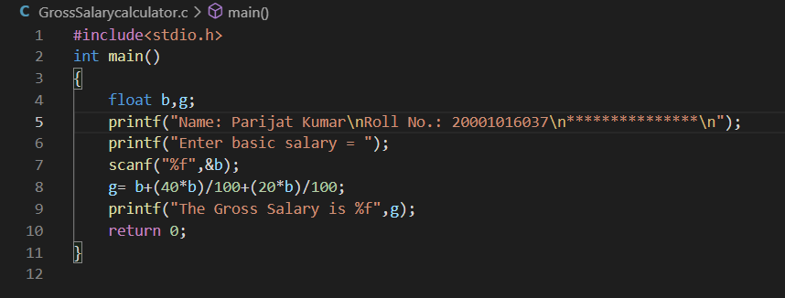

Output:

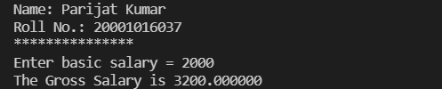

Question 2)

Aim: The distance between two cities (in km.) is input through the keyboard. Write a program to convert and print this distance in meters, feet, inches and centimeters.

Program:

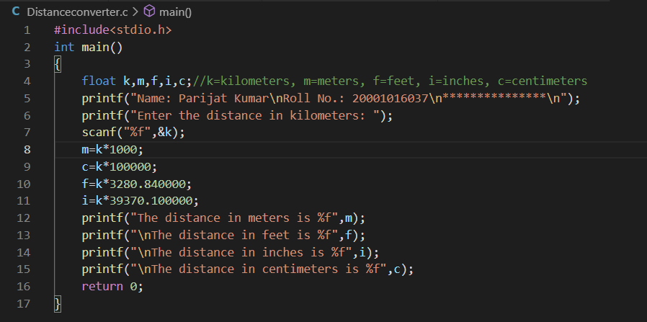

Output:

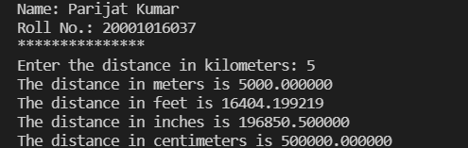

Question 3)

Aim: If the marks obtained by a student in five different subjects are input through the keyboard, find out the aggregate marks and percentage marks obtained by the student. Assume that the maximum marks that can be obtained by a student in each subject is 100.

Program:

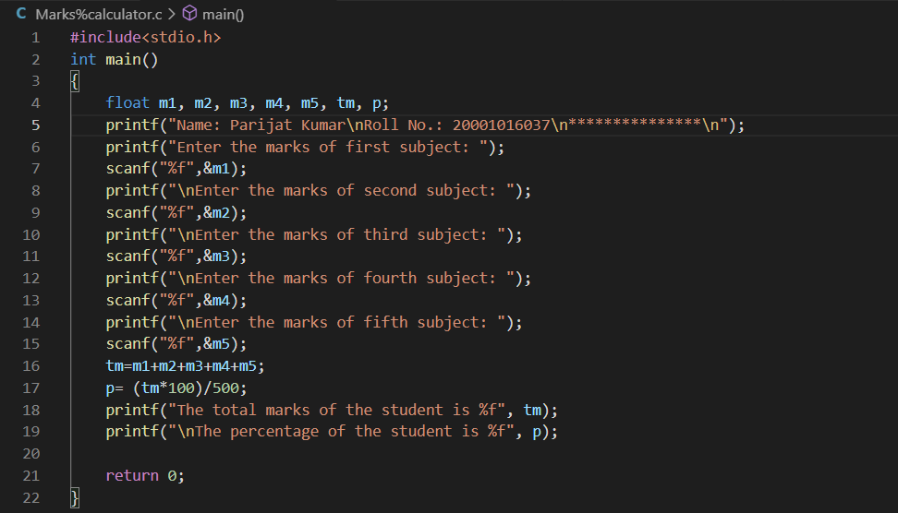

Output:

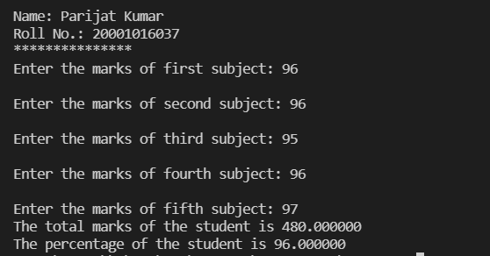

Question 4)

Aim: Temperature of a city in Fahrenheit degrees is input through the keyboard. Write a program to convert this temperature into Centigrade degrees.

Program:

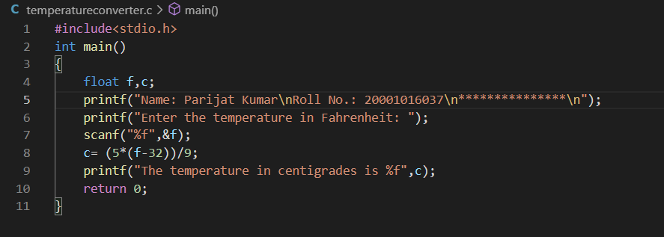

Output:

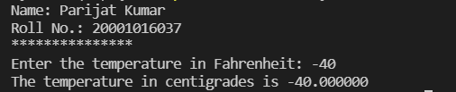

Question 5)

Aim: The length & breadth of a rectangle and radius of a circle are input through the keyboard. Write a program to calculate the area & perimeter of the rectangle, and the area & circumference of the circle.

Program:

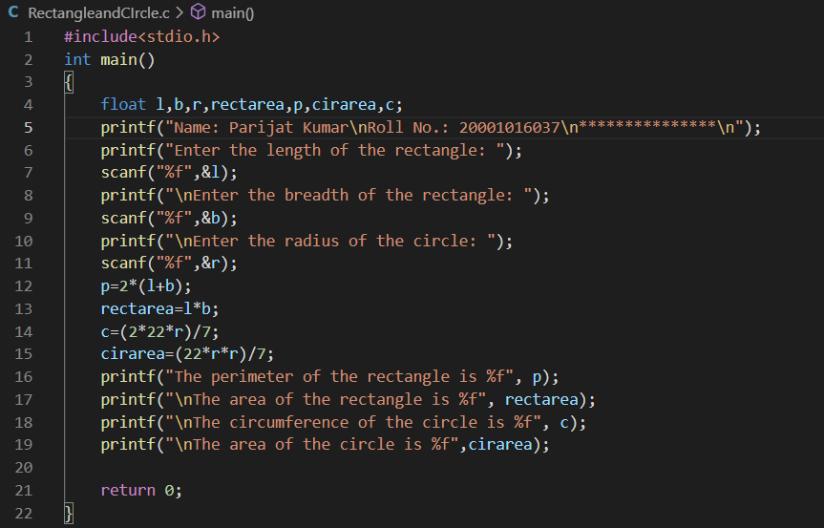

Output:

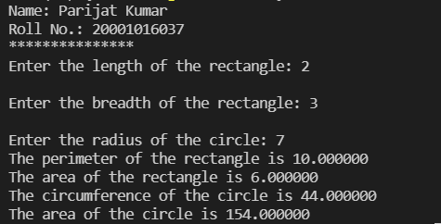

Question 6)

Aim: Two numbers are input through the keyboard into two locations C and D. Write a program to interchange the contents of C and D.

Program:

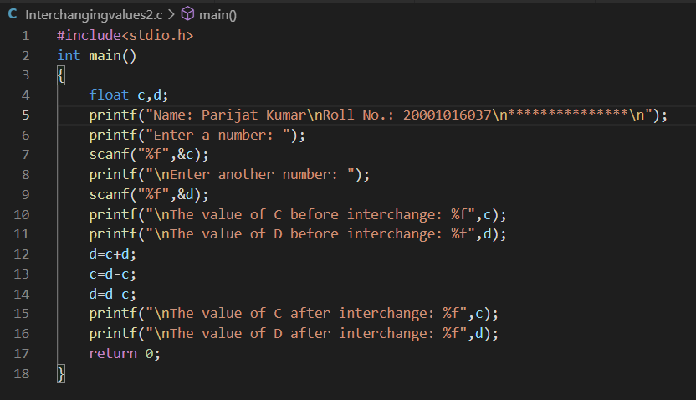

Output:

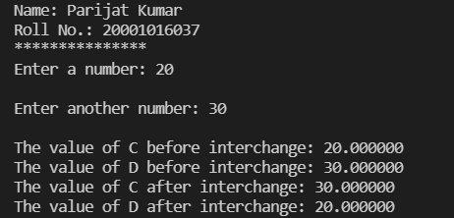

Question 7)

Aim: If a five-digit number is input through the keyboard, write a program to calculate the sum of its digits.

(Hint: Use the modulus operator ‘%’)

Program:

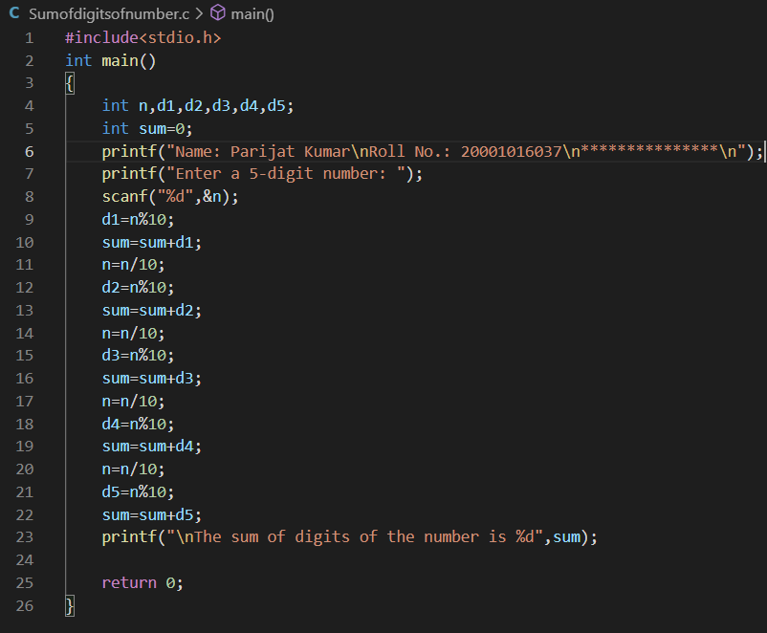

Output:

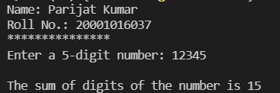

Question 8)

Aim: If a five-digit number is input through the keyboard, write a program to reverse the number.

Program:

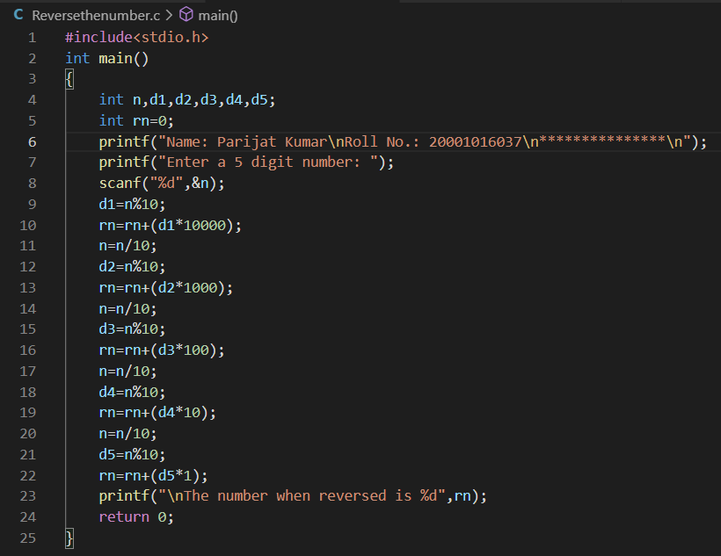

Output:

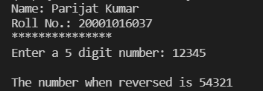

Question 9)

Aim: If a four-digit number is input through the keyboard, write a program to obtain the sum of the first and last digit of this number.

Program:

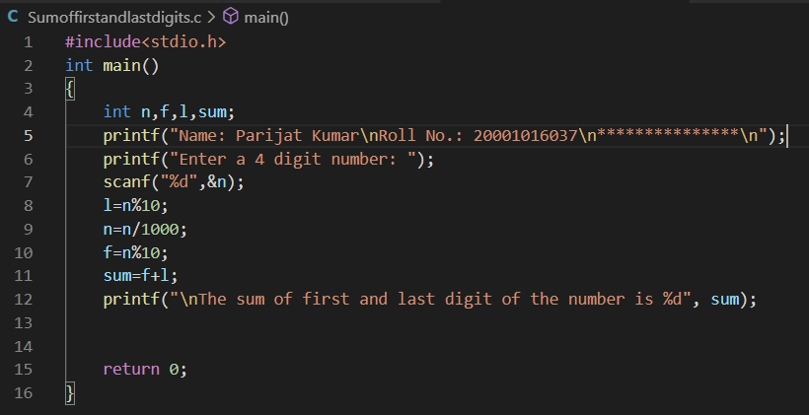

Output:

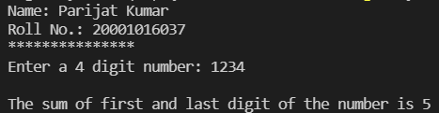

Question 10)

Aim: In a town, the percentage of men is 52. The percentage of total literacy is 48. If total percentage of literate men is 35 of the total population, write a program to find the total number of illiterate men and women if the population of the town is 80,000.

Program:

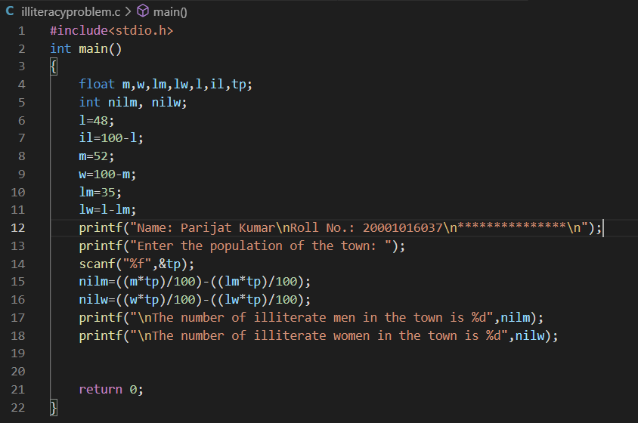

Output:

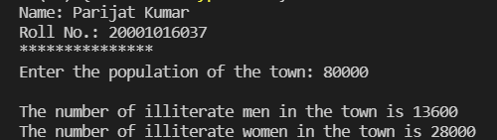

Question 11)

Aim: A cashier has currency notes of denominations 10, 50 and 100. If the amount to be withdrawn is input through the keyboard in hundreds, find the total number of currency notes of each denomination the cashier will have to give to the withdrawer.

Program:

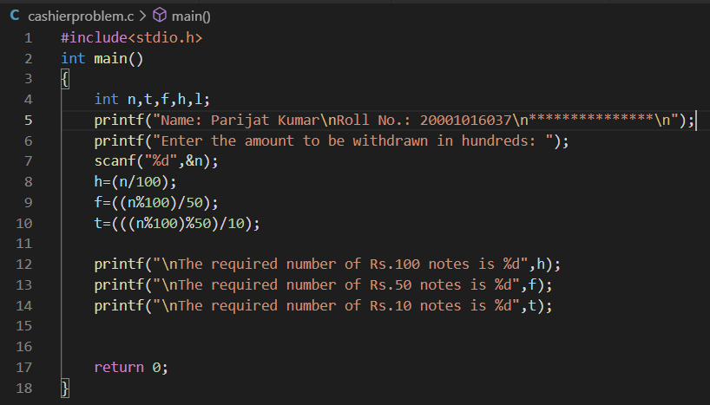

Output:

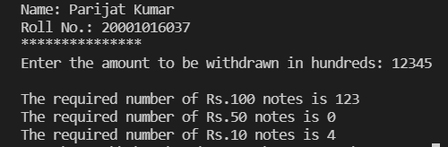

Question 12)

Aim: If the total selling price of 15 items and the total profit earned on them is input through the keyboard, write a program to find the cost price of one item.

Program:

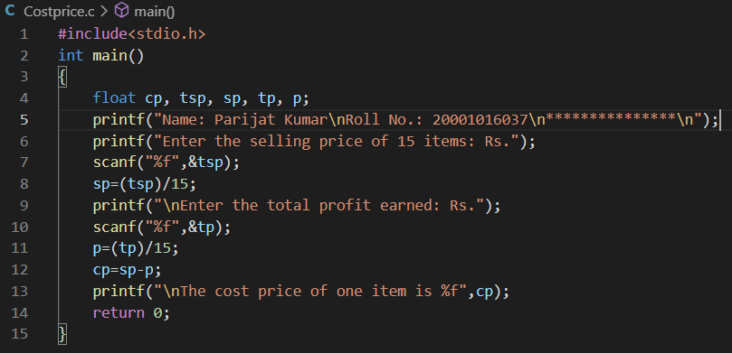

Output:

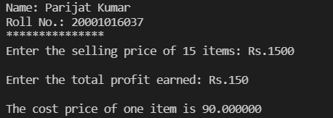

Question 13)

Aim: If a five-digit number is input through the keyboard, write a program to print a new number by adding one to each of its digits. For example, if the number that is input is 12391 then the output should be displayed as 23402.

Program:

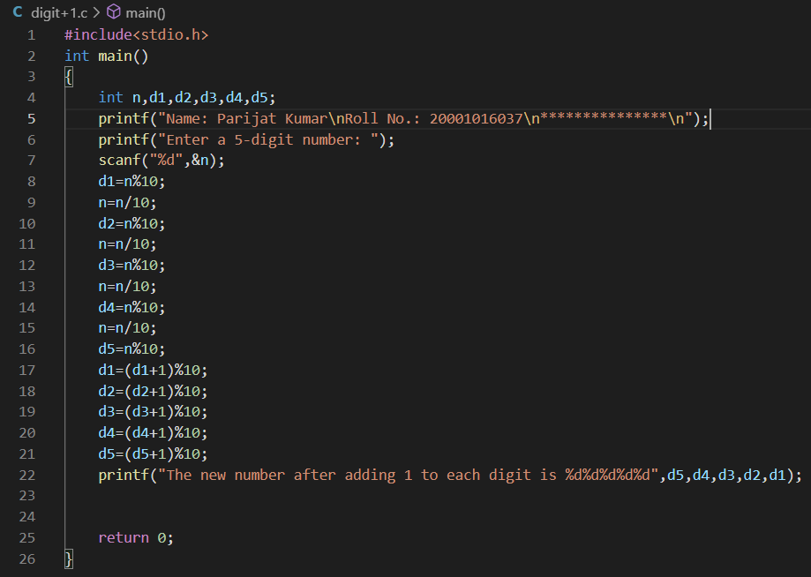

Output:

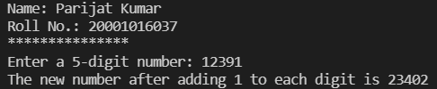

Question 14)

Aim: Write a program to convert an alphabet input in lower case to upper case.

Program:

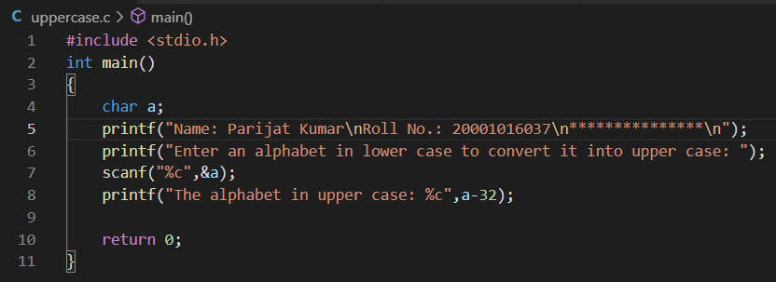

Output:

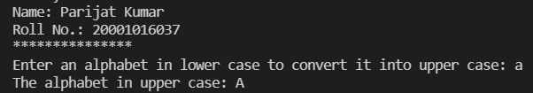

Chapter-2

Question-1)

Aim: If cost price and selling price of an item is input through the keyboard, write a program to determine whether the seller has made profit or incurred loss. Also determine how much profit he made or loss he incurred.

Program:

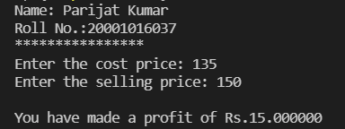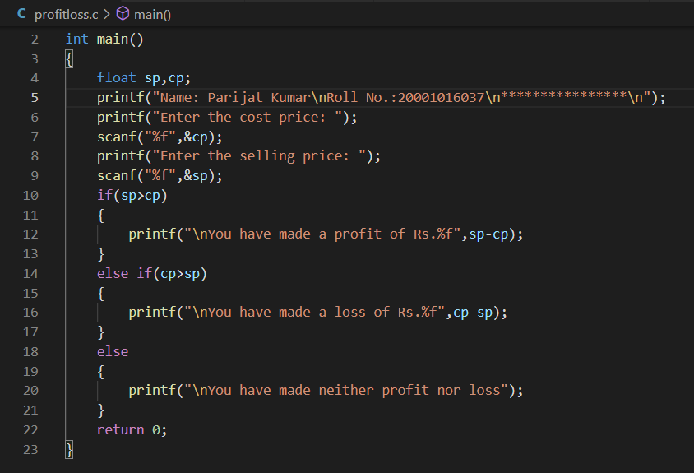Output:

Question 2)

Aim: Any integer is input through the keyboard. Write a program to find out whether it is an odd number or even number.

Program:

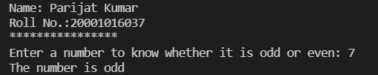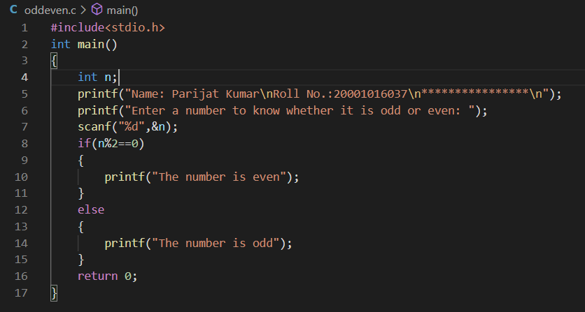Output:

Question 3)

Aim: Any year is input through the keyboard. Write a program to determine whether the year is a leap year or not.

Program:

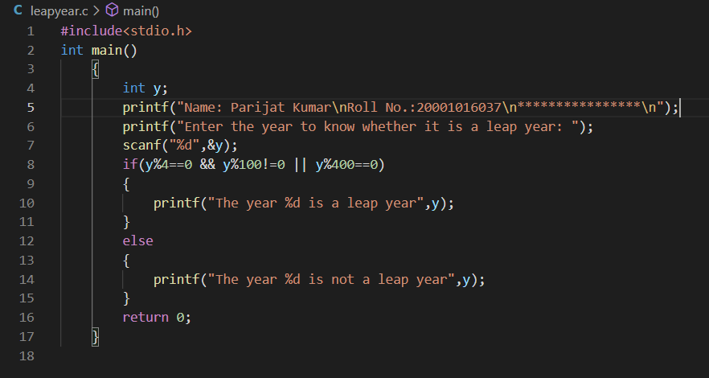

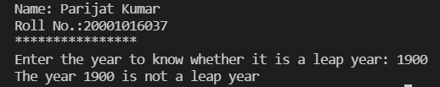Output:

Question 4)

Aim: According to the Gregorian calendar, it was Monday on the date 01/01/1900. If any year is input through the keyboard write a program to find out what is the day on 1st January of this year.

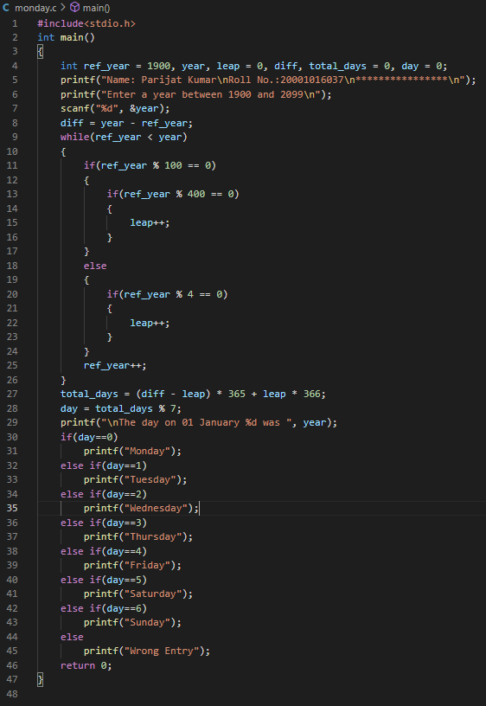Program:

Output:

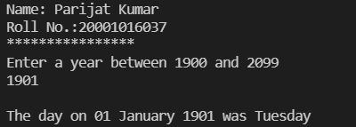

Question 5)

Aim: A five-digit number is entered through the keyboard. Write a program to obtain the reversed number and to determine whether the original and reversed numbers are equal or not.

Program:

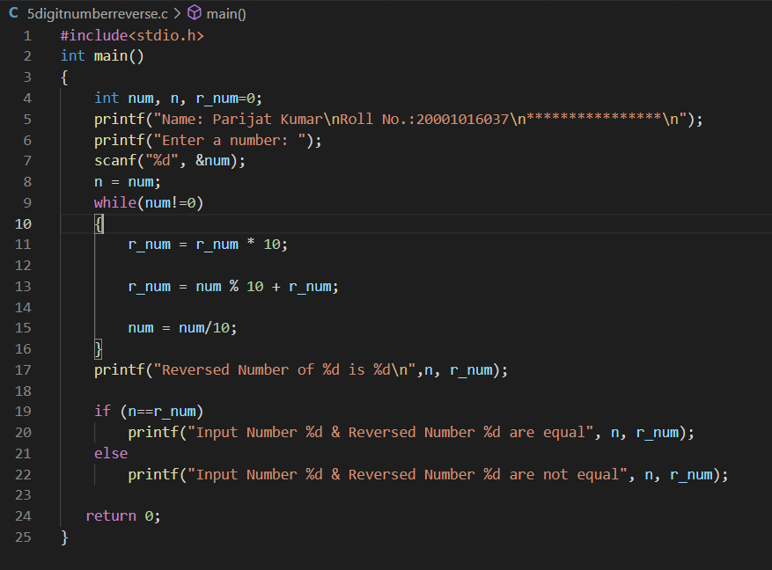

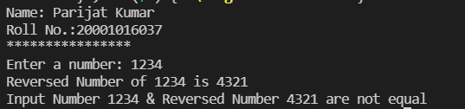Output:

Question 6)

Aim: If the ages of Ram, Shyam and Ajay are input through the keyboard, write a program to determine the youngest of the three.

Program:

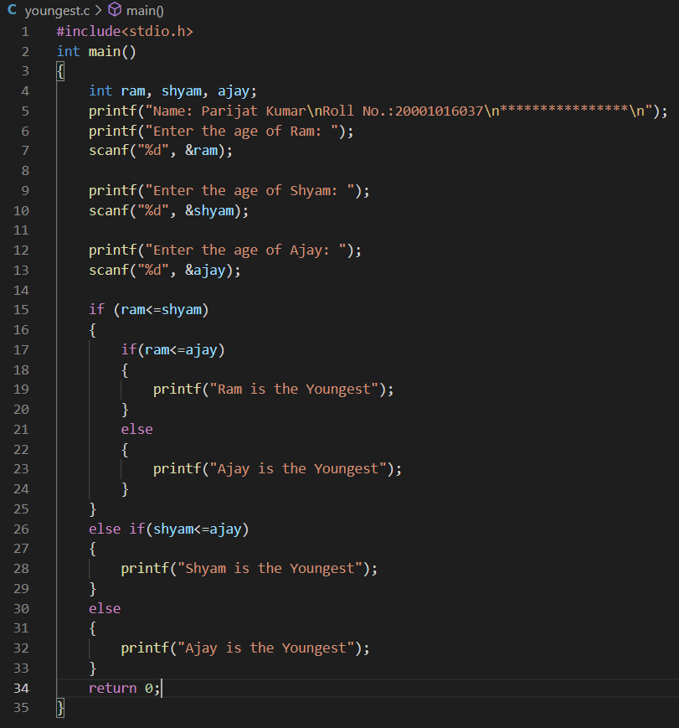

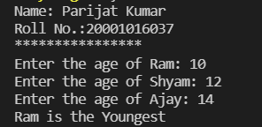Output:

Question 7)

Aim: Write a program to check whether a triangle is valid or not, when the three angles of the triangle are entered through the keyboard. A triangle is valid if the sum of all the three angles is equal to 180 degrees.

Program:

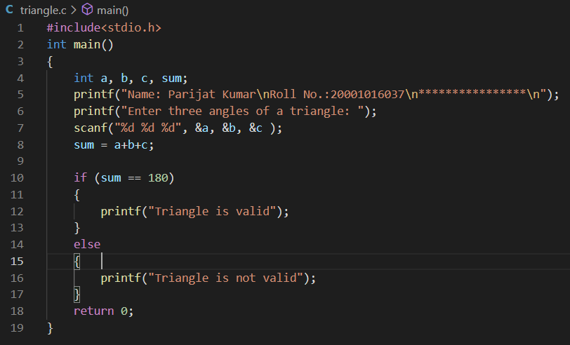

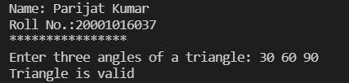Output:

Question 8)

Aim: Find the absolute value of a number entered through the keyboard.

Program:

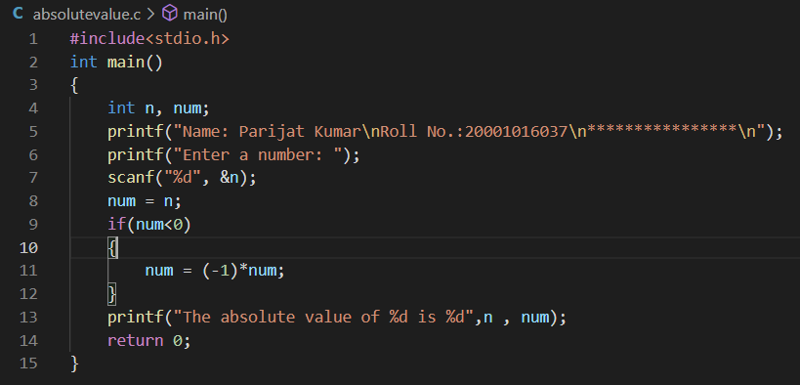

Output:

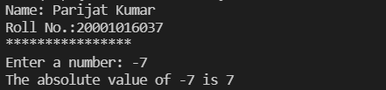

Question 9)

Aim: Given the length and breadth of a rectangle, write a program to find whether the area of the rectangle is greater than its perimeter.

Program:

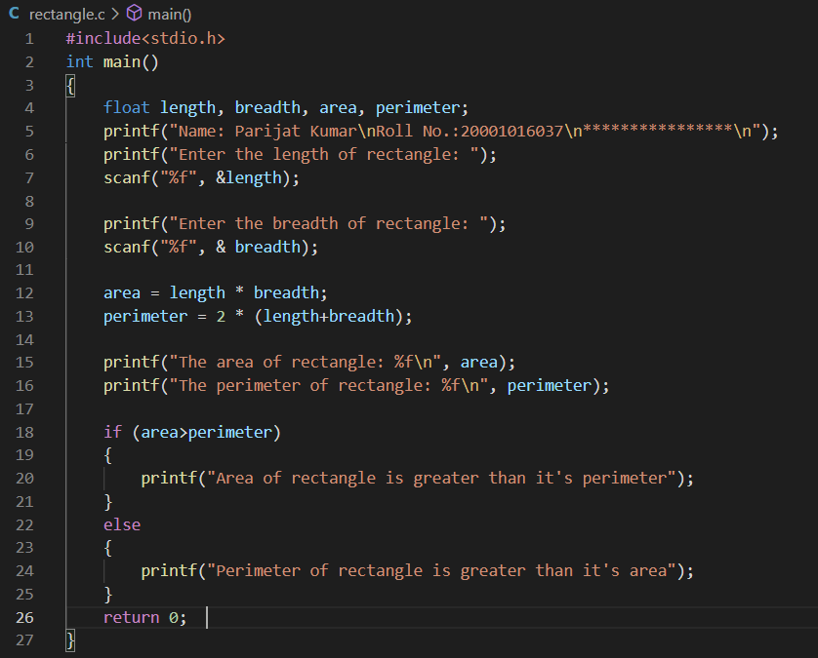

Output:

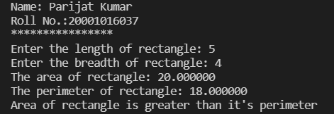

Question 10)

Aim: Given three points (x1, y1), (x2, y2) and (x3, y3), write a program to check if all the three points fall on one straight line.

Program:

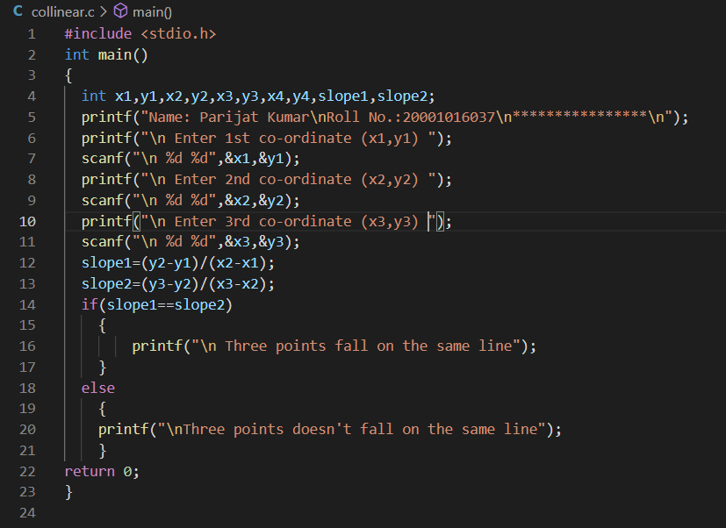

Output:

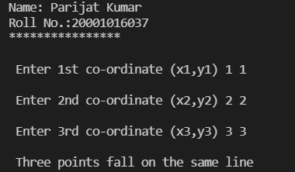

Question 11)

Aim: Given the coordinates (x, y) of a center of a circle and it’s radius, write a program which will determine whether a point lies inside the circle, on the circle or outside the circle.

Program:

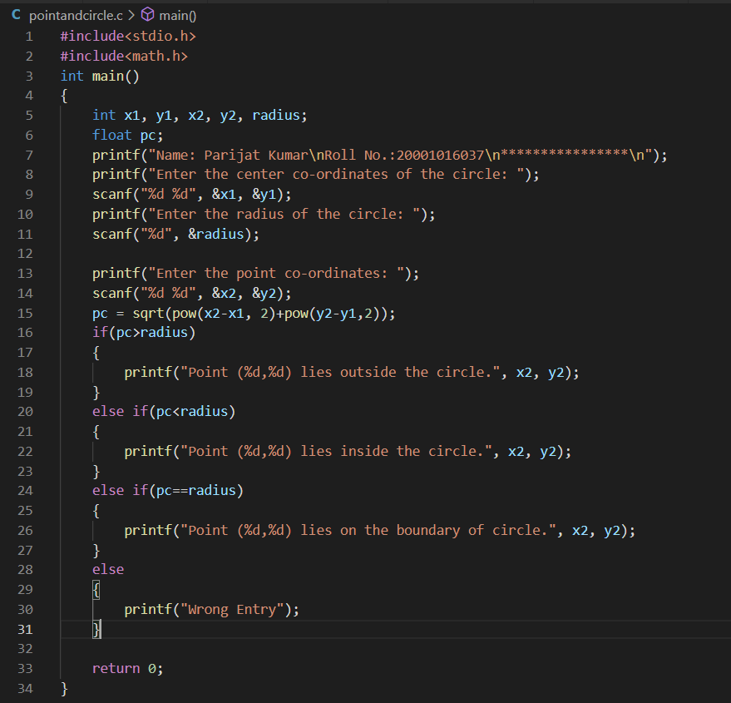

Output:

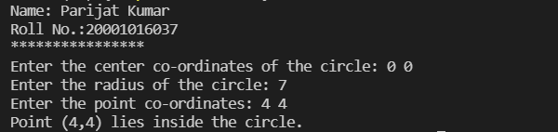

Question 12)

Aim: Given a point (x, y), write a program to find out if it lies on the x-axis, y-axis or at the origin, viz. (0, 0).

Program:

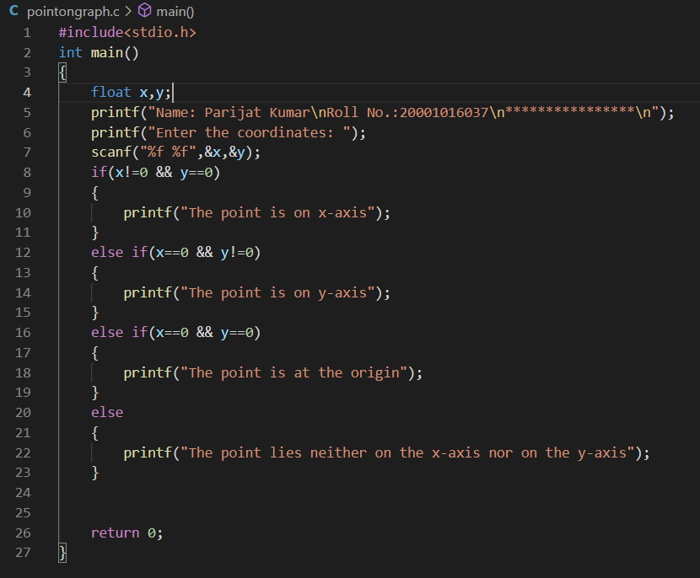

Output:

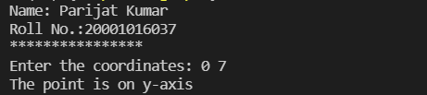

Question 13)

Aim: Any year is entered through the keyboard, write a program to determine whether the year is leap or not. Use the logical operators && and ||.

Program:



Output:

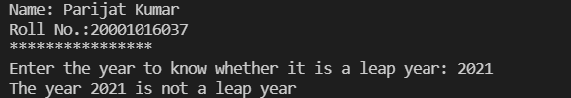

Question 14)

Aim: Any character is entered through the keyboard, write a program to determine whether the character entered is a capital letter, a small case letter, a digit or a special symbol.

Program:

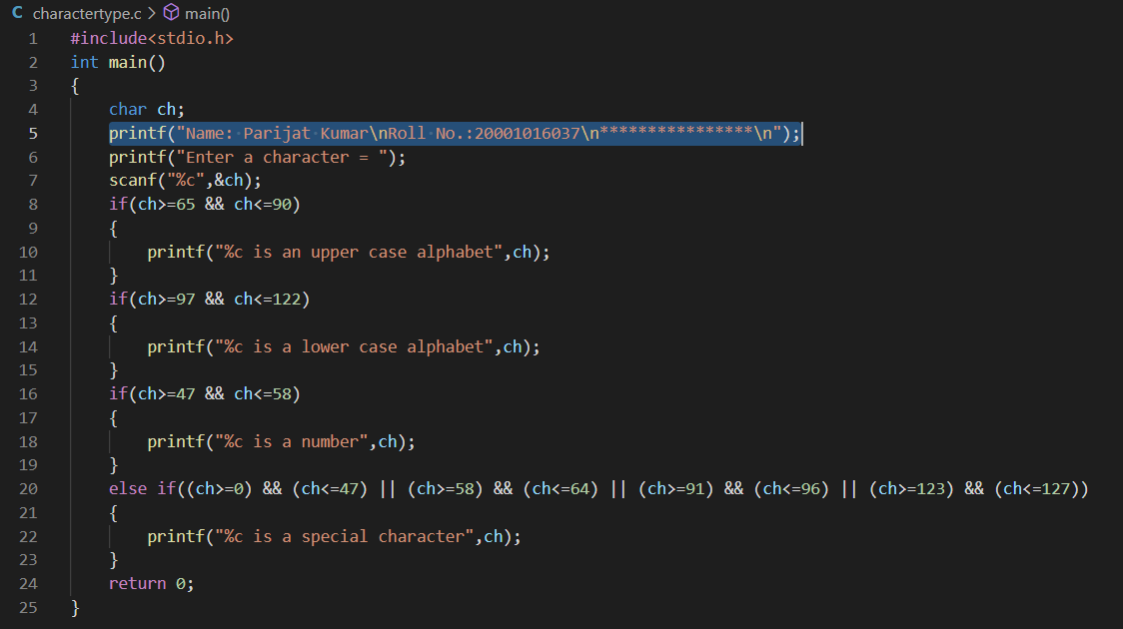

Output:

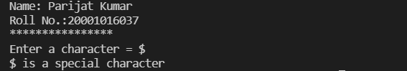

Question 15)

Aim: An Insurance company follows following rules to calculate premium.

(1) If a person’s health is excellent and the person is between 25 and 35 years of age and lives in a city and is a male then the premium is Rs. 4 per thousand and his policy amount cannot exceed Rs. 2 lakhs.

(2) If a person satisfies all the above conditions except that the sex is female then the premium is Rs. 3 per thousand and her policy amount cannot exceed Rs. 1 lakh.

(3) If a person’s health is poor and the person is between 25 and 35 years of age and lives in a village and is a male then the premium is Rs. 6 per thousand and his policy cannot exceed Rs. 10,000.

(4) In all other cases the person is not insured.

Write a program to output whether the person should be insured or not, his/her premium rate and maximum amount for which he/she can be insured.

Program:

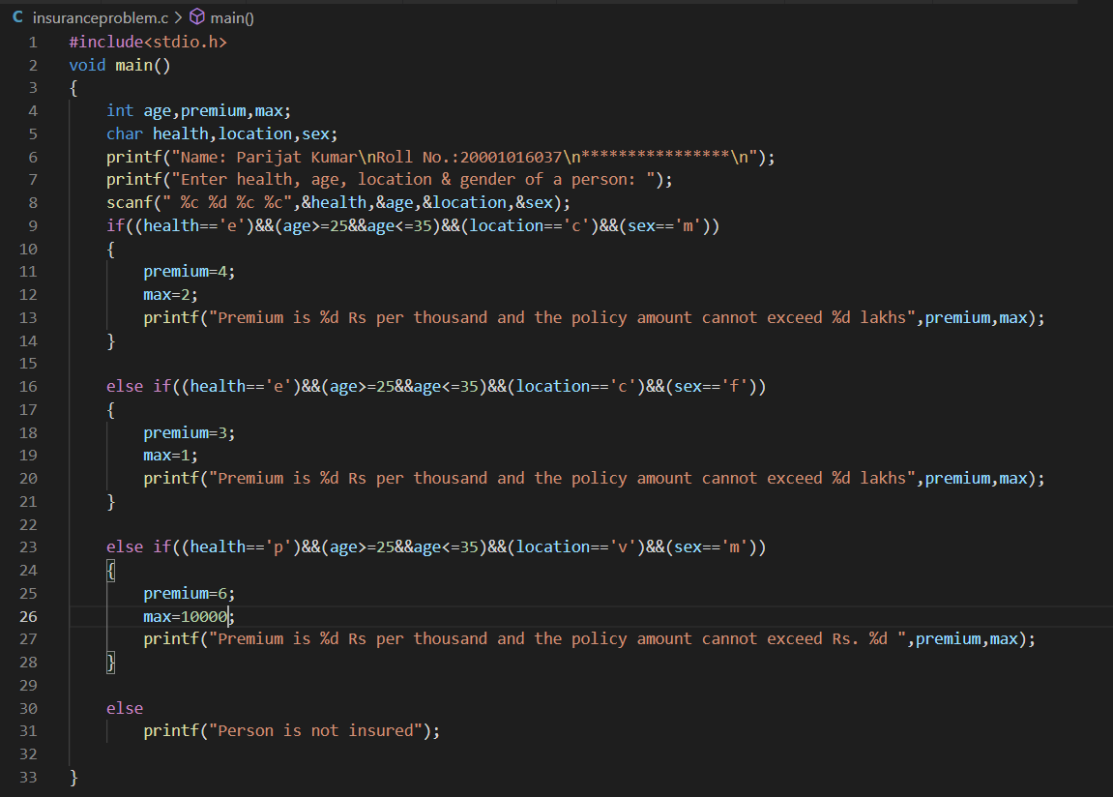

Output:

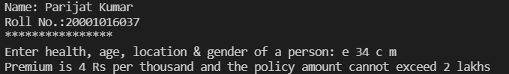

Question 16)

Aim: A certain grade of steel is graded according to the following conditions:

(i) Hardness must be greater than 50

(ii) Carbon content must be less than 0.7

(iii) Tensile strength must be greater than 5600

The grades are as follows:

Grade is 10 if all three conditions are met. Grade is 9 if conditions (i) and (ii) are met. Grade is 8 if conditions (ii) and (iii) are met. Grade is 7 if conditions (i) and (iii) are met. Grade is 6 if only one condition is met. Grade is 5 if none of the conditions are met.

Write a program, which will require the user to give values of hardness, carbon content and tensile strength of the steel under consideration and output the grade of the steel.

Program:

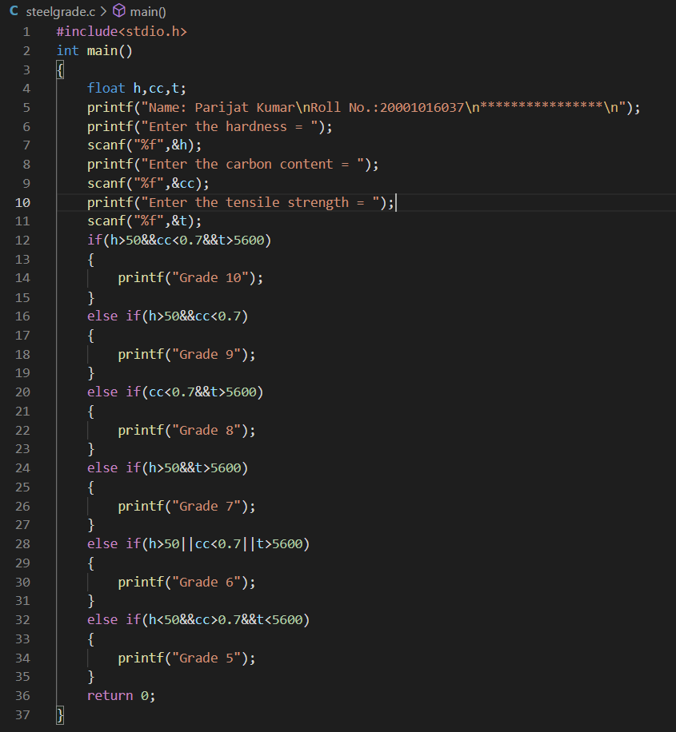

Output:

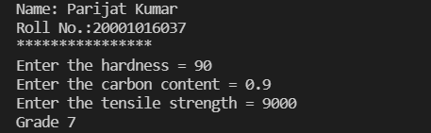

Question 17)

Aim: A library charges a fine for every book returned late. For first 5 days the fine is 50 paise, for 6-10 days fine is one rupee and above 10 days fine is 5 rupees. If you return the book after 30 days your membership will be cancelled. Write a program to accept the number of days the member is late to return the book and display the fine or the appropriate message.

Program:

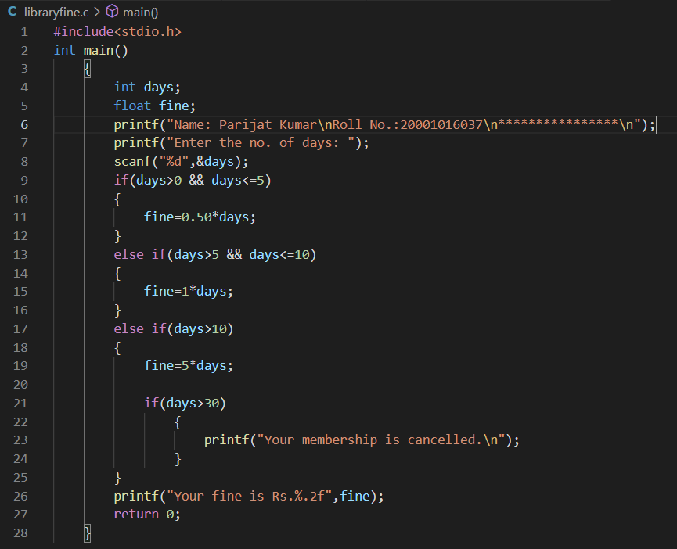

Output:

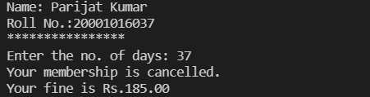

Question 18)

Aim: If the three sides of a triangle are entered through the keyboard, write a program to check whether the triangle is valid or not. The triangle is valid if the sum of two sides is greater than the largest of the three sides.

Program:

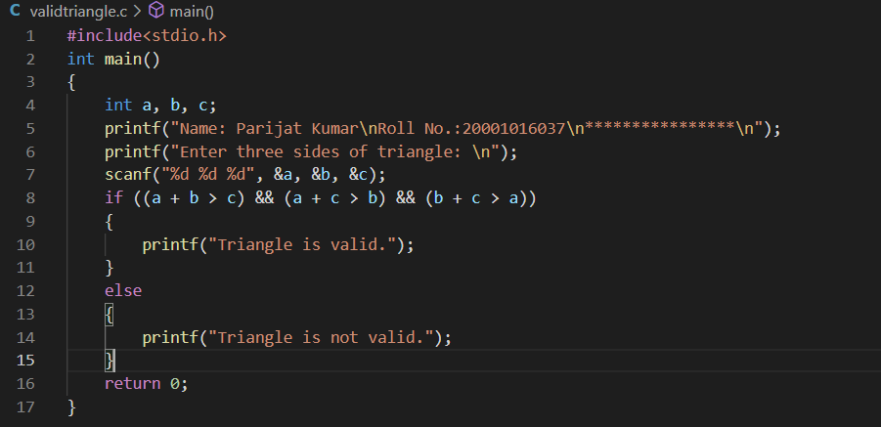

Output:

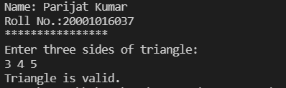

Chapter-3

Question 1)

Aim: Write a program to calculate overtime pay of 10 employees. Overtime is paid at the rate of Rs. 12.00 per hour for every hour worked above 40 hours. Assume that employees do not work for fractional part of an hour.

Program:

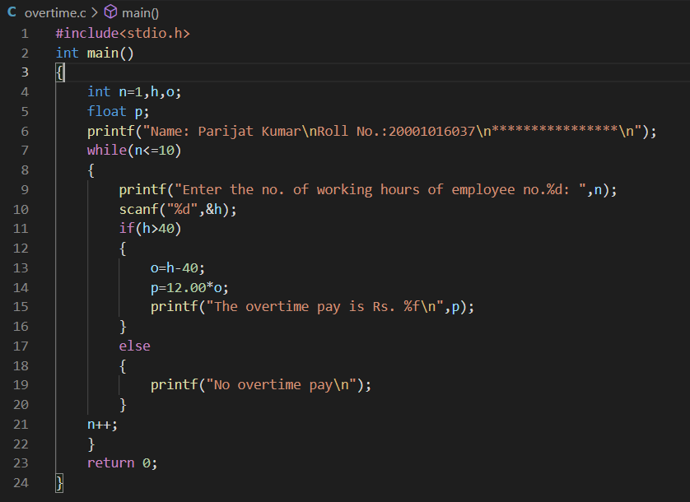

Output: 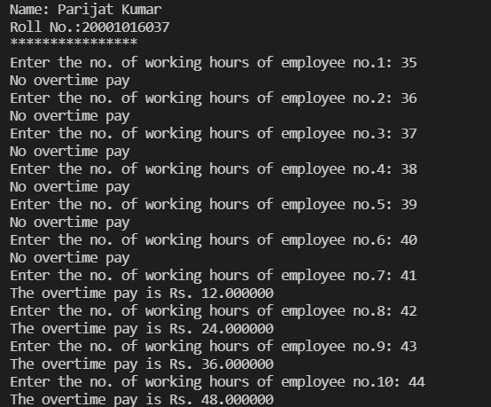

Question 2)

Aim: Write a program to find the factorial value of any number entered through the keyboard.

Program:

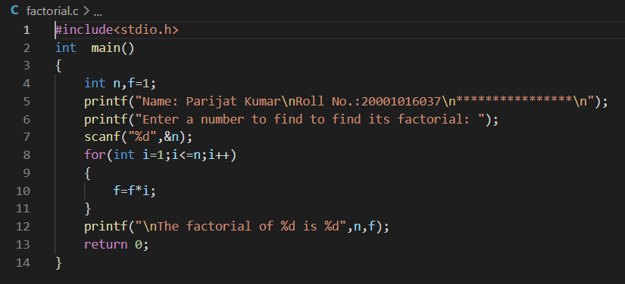

Output:

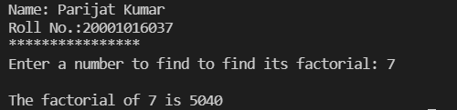

Question 3)

Aim: Two numbers are entered through the keyboard. Write a program to find the value of one number raised to the power of another.

Program:

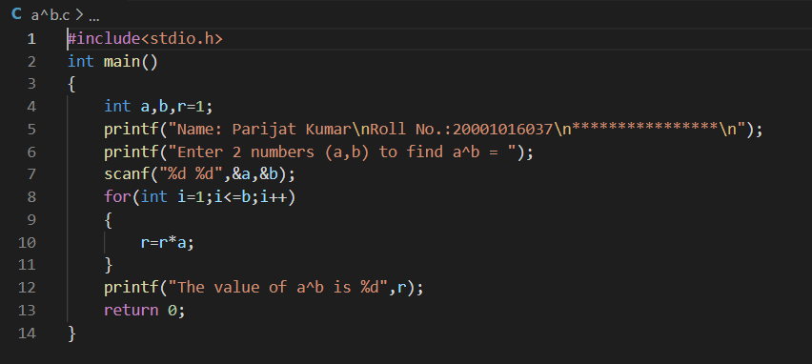

Output:

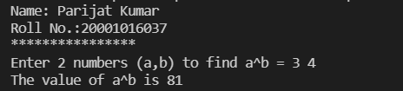

Question 4)

Aim: Write a program to print all the ASCII values and their equivalent characters using a while loop. The ASCII values vary from 0 to 255.

Program:

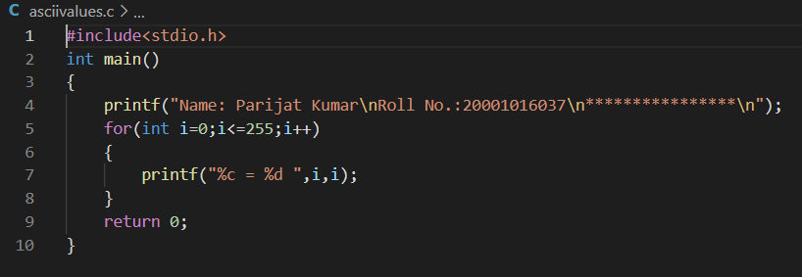

Output:

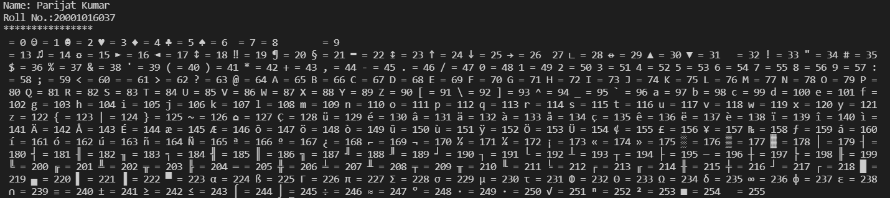

Question 5)

Aim: Write a program to print out all Armstrong numbers between 1 and 500. If sum of cubes of each digit of the number is equal to the number itself, then the number is called an Armstrong number.

Program:

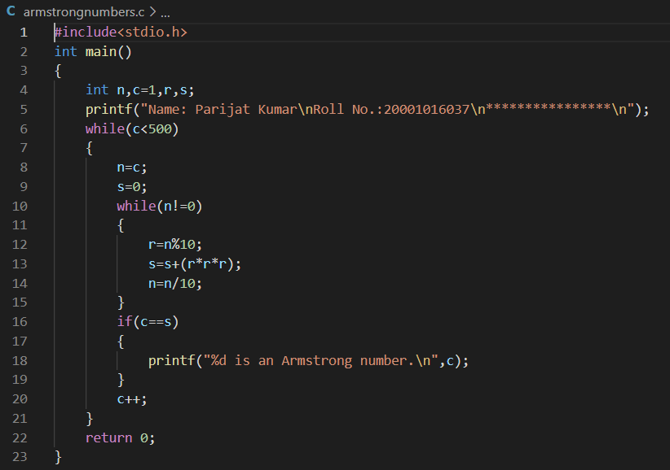

Output:

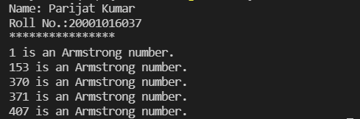

Question 6)

Aim: Write a program for a matchstick game being played between the computer and a user. Your program should ensure that thecomputer always wins. Rules for the game are as follows:

− There are 21 matchsticks.

− The computer asks the player to pick 1, 2, 3, or 4 matchsticks.

− After the person picks, the computer does its picking.

− Whoever is forced to pick up the last matchstick loses the game.

Program:

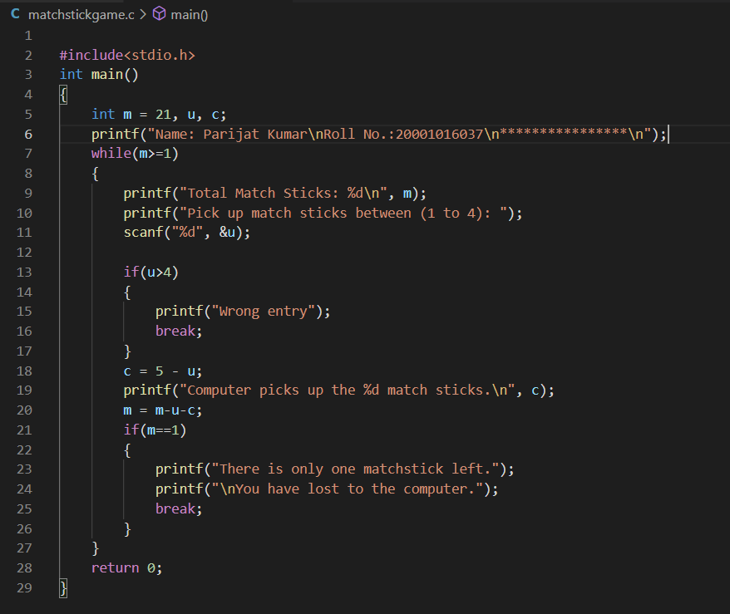

Output:

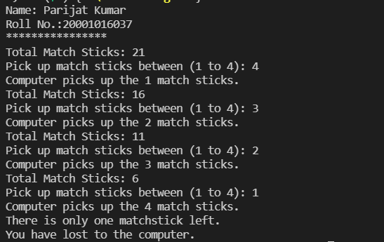

Question 7)

Aim: Write a program to enter the numbers till the user wants and at the end it should display the count of positive, negative and zeros entered.

Program:

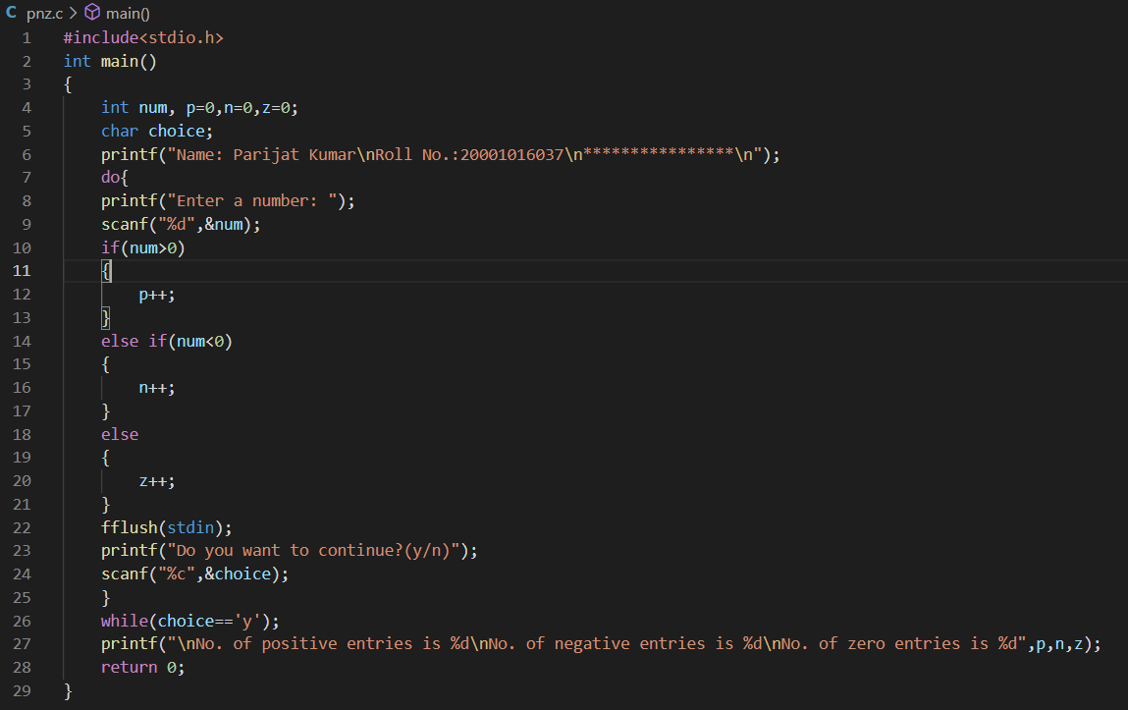

Output:

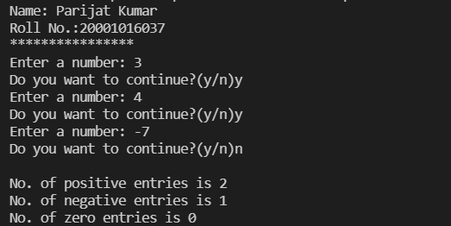

Question 8)

Aim: Write a program to find the octal equivalent of the entered number.

Program:

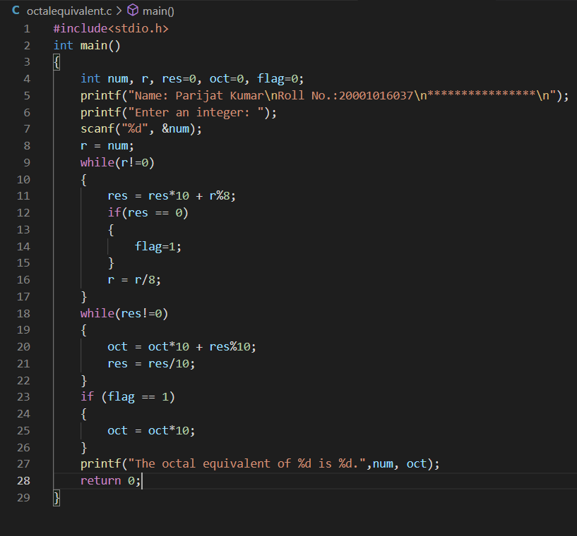

Output:

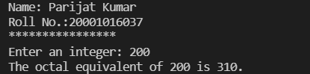

Question 9)

Aim: Write a program to find the range of a set of numbers. Range is the difference between the smallest and biggest number in the list.

Program:

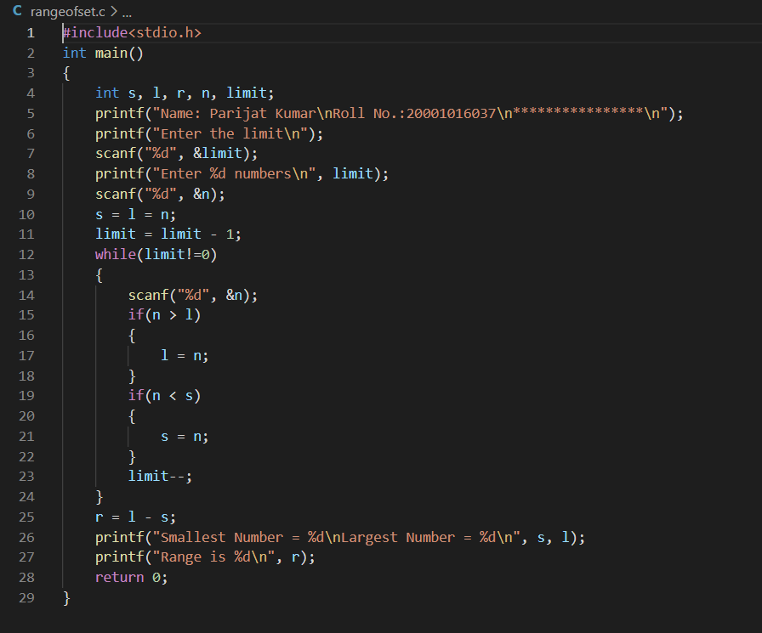

Output:

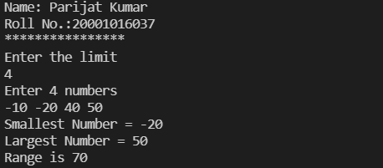

Chapter-4

Question 1)

Aim: Write a menu driven program which has following options:

1. Factorial of a number.

2. Prime or not

3. Odd or even

4. Exit

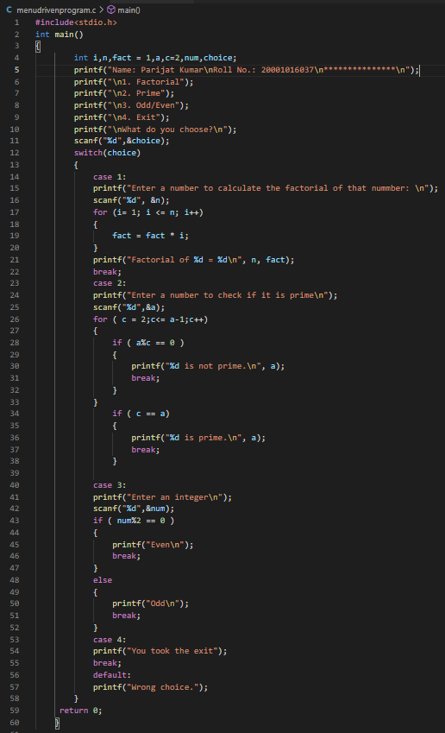Program:

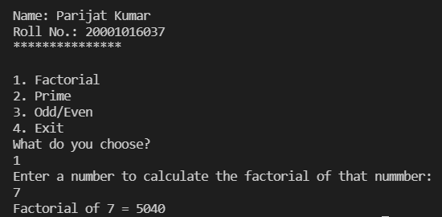Output:

Question 2)

Aim: Write a program which to find the grace marks for a student using switch. The user should enter the class obtained by the student and the number of subjects he has failed in.

− If the student gets first class and the number of subjects, he failed in is greater than 3, then he does not get any grace. If the number of subjects he failed in is less than or equal to 3 then the grace is of 5 marks per subject.

− If the student gets second class and the number of subjects, he failed in is greater than 2, then he does not get any grace. If the number of subjects he failed in is less than or equal to 2 then the grace is of 4 marks per subject.

− If the student gets third class and the number of subjects, he failed in is greater than 1, then he does not get any grace. If the number of subjects he failed in is equal to 1 then the grace is of 5 marks per subject

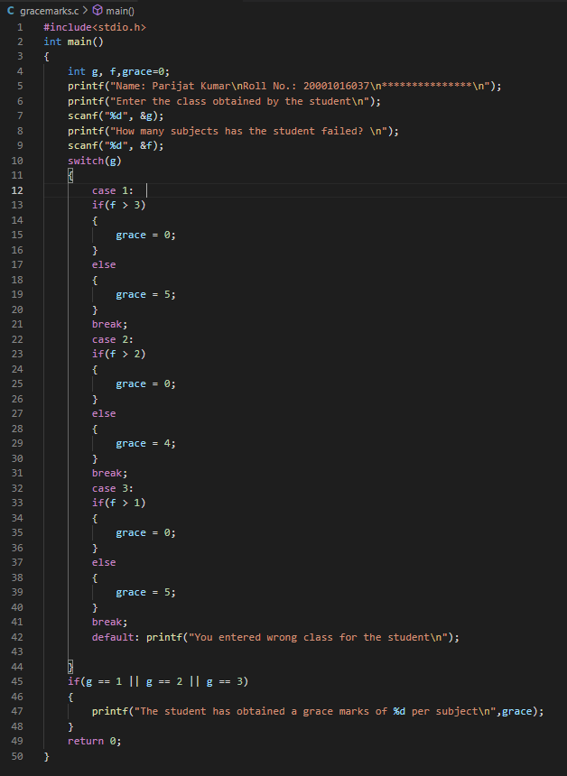Program:

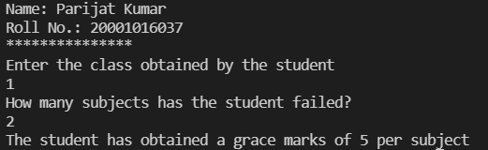Output:

Chapter-5

Question 1)

Aim: Write a function to calculate the factorial value of any integer entered through the keyboard.

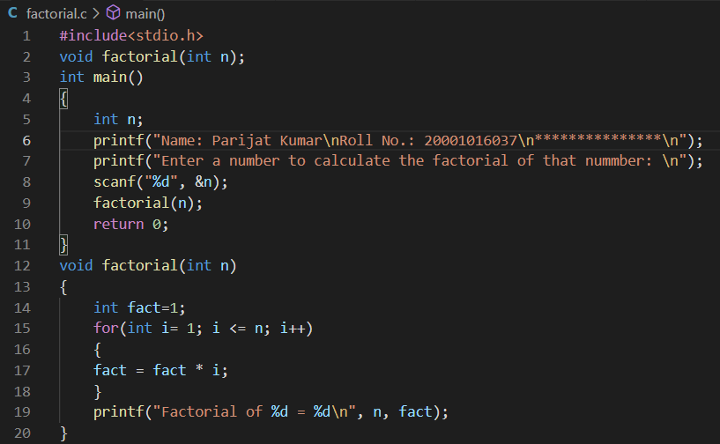Program:

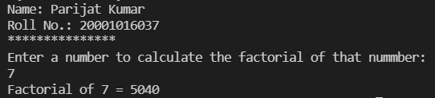Output:

Question 2)

Aim: Write a function power (a, b), to calculate the value of a raised to b.

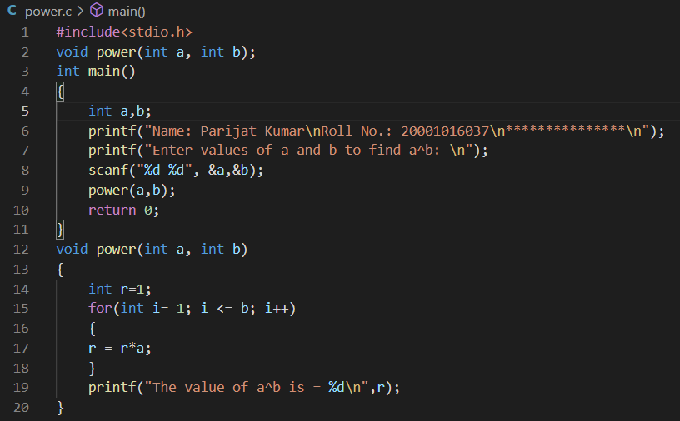Program:

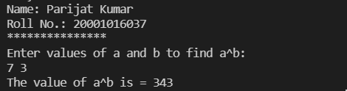Output:

Question 3)

Aim: Write a general-purpose function to convert any given year into its roman equivalent.

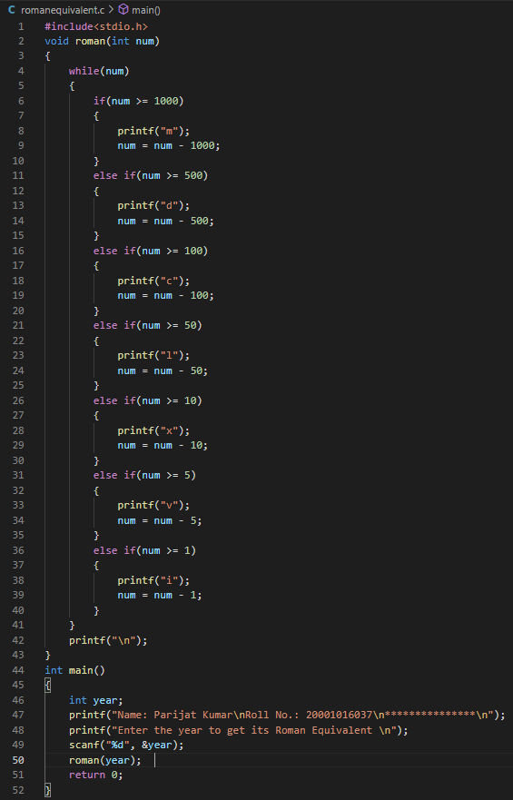Program:

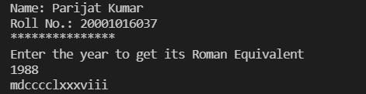Output:

Question 4)

Aim: A positive integer is entered through the keyboard. Write a function to obtain the prime factors of this number.

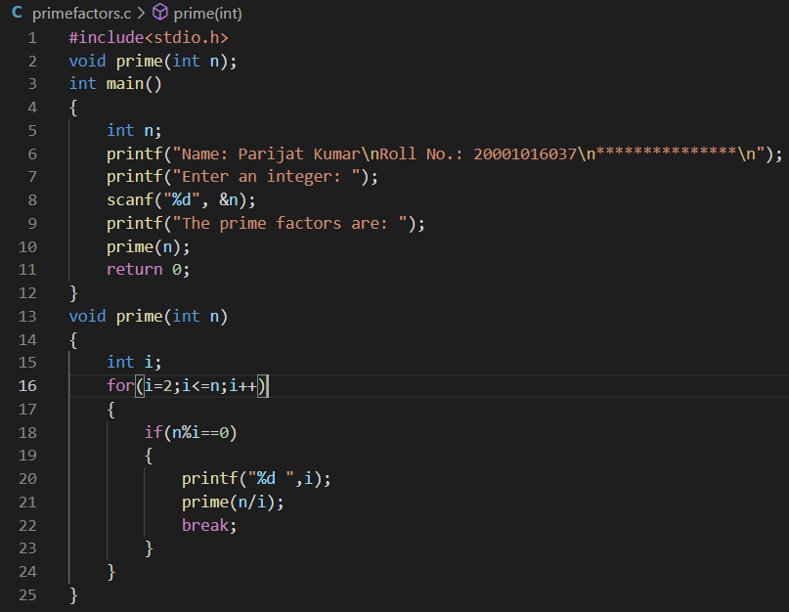Program:

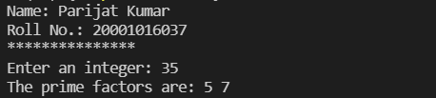Output:

Question 5)

Aim: A 5-digit positive integer is entered through the keyboard, write a function to calculate sum of digits of the 5-digit number:

1) Without using recursion 2) Using recursion

Program:

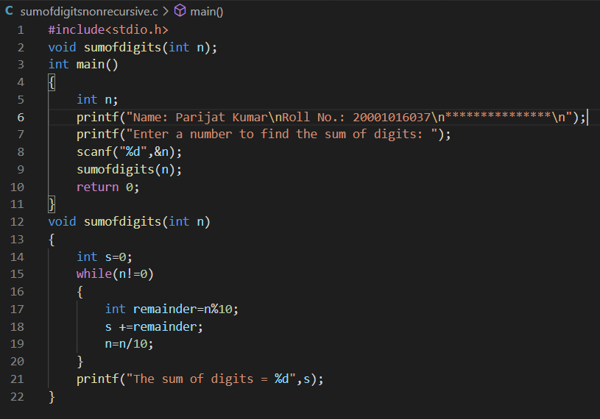1)

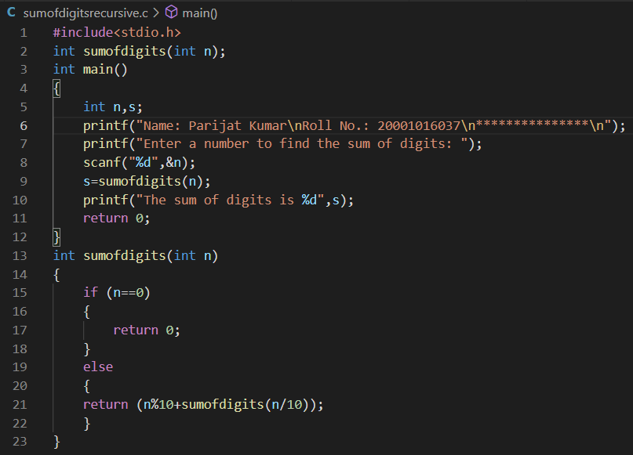2)

Output:

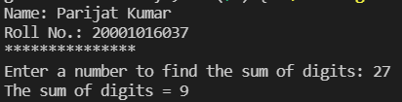1)

2)

Question 6)

Aim: Write a recursive function to obtain the first 25 numbers of a Fibonacci sequence.

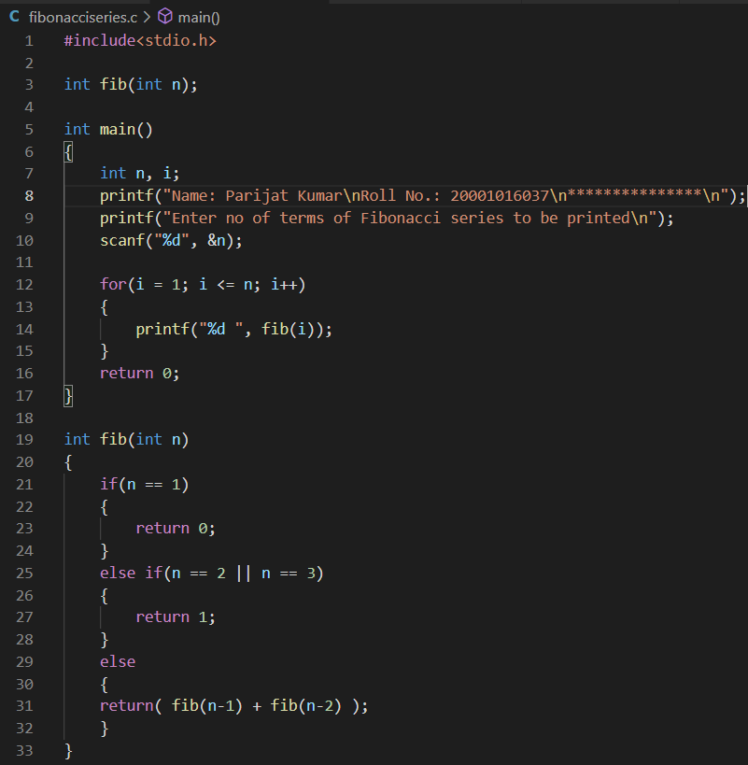Program:

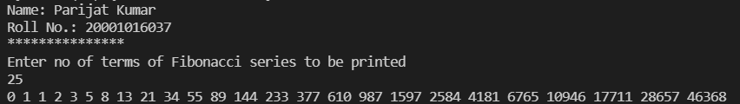Output:

Question 7)

Aim: A positive integer is entered through the keyboard, write a function to find the binary equivalent of this number using recursion.

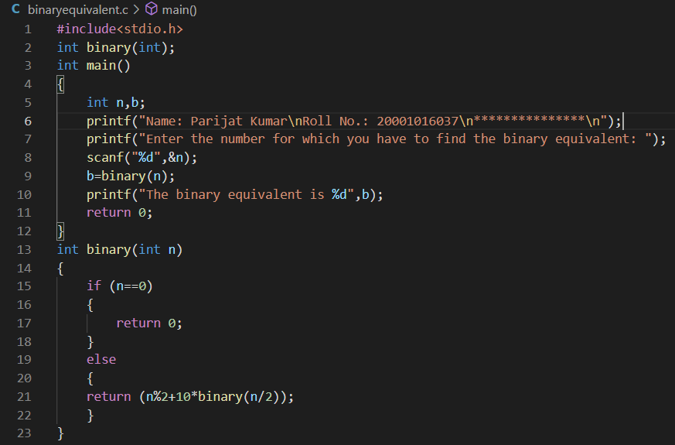Program:

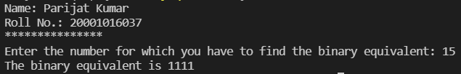Output:

Question 8)

Aim: Write a recursive function to obtain the running sum of first 25 natural numbers.

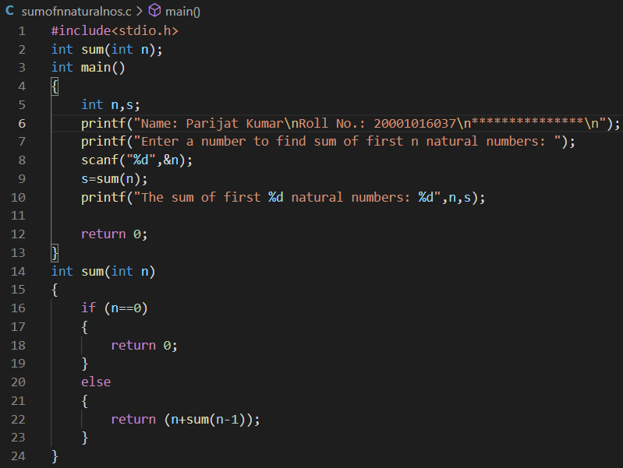Program:

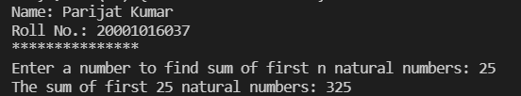Output:

Question 9)

Aim: Write a C function to evaluate the series sin(x) = x − (x^3 / 3!) + (x^5 / 5!) − (x^7/ 7!) +…….

Program: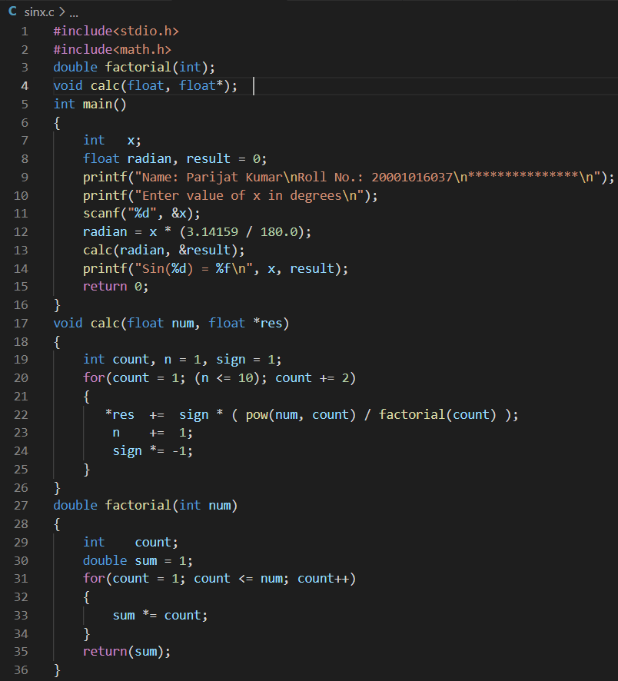

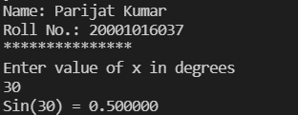Output:

Question 10)

Aim: Given three variables x, y, z, write a function to circularly shift their values to right. In other words, if x = 5, y = 8, z = 10 after circular shift y = 5, z = 8, x =10 after circular shift y = 5, z = 8 and x = 10. Call the function with variables a, b, c to circularly shift values.

Program:

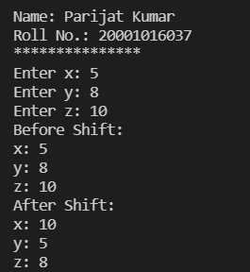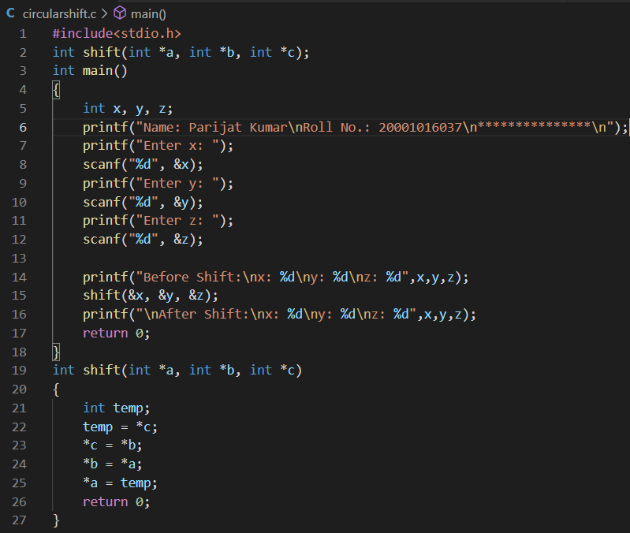Output:

Question 11)

Aim: If the lengths of the sides of a triangle are denoted by a, b, and c, then area of triangle is given by area = S(S − a)(S − b)(S − c) where, S = ( a + b + c ) / 2.

Program:

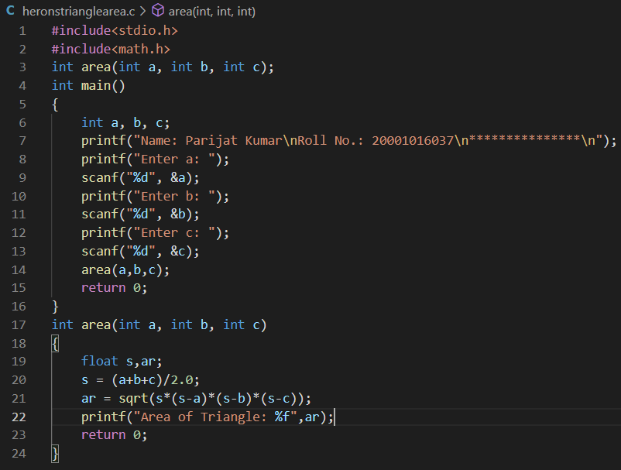

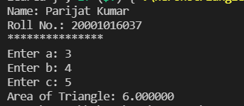Output:

Question 12)

Aim: Write a function to compute the distance between two points and use it to develop another function that will compute the area of the triangle whose vertices are A (x1, y1), B (x2, y2), and C (x3, y3). Use these functions to develop a function which returns a value 1 if the point (x, y) lines inside the triangle ABC, otherwise a value 0.

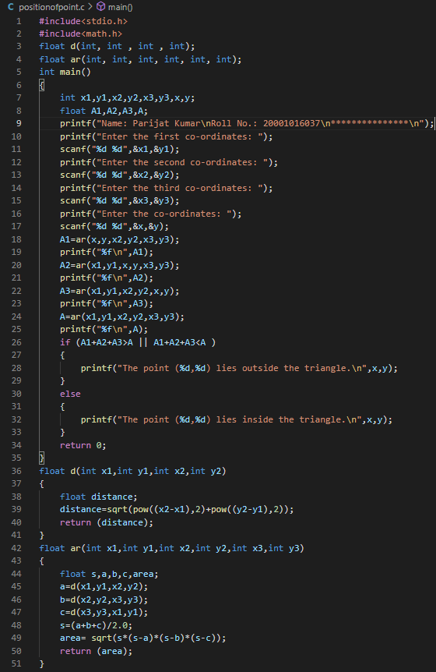Program:

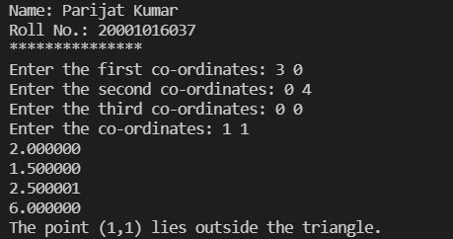Output:

Question 13)

Aim: Write a function to compute the greatest common divisor given by Euclid’s algorithm.

Program:

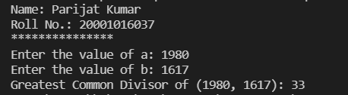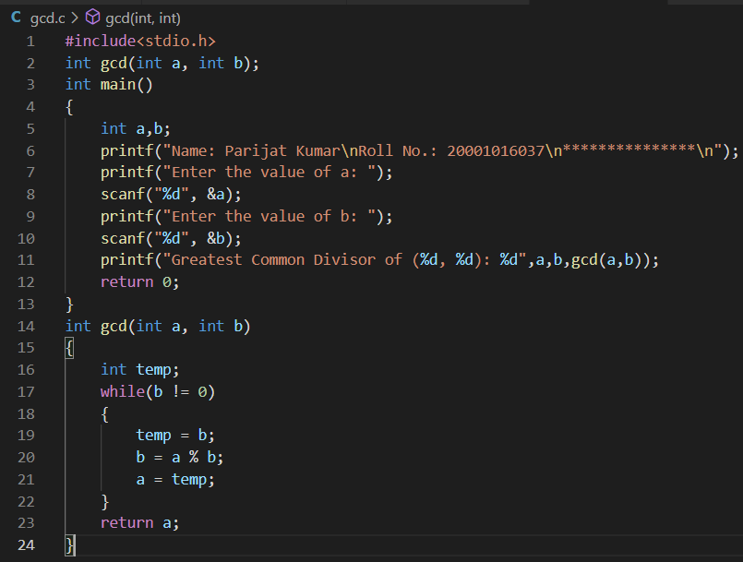Output:

Chapter-8

Question 1)

Aim: Twenty-five numbers are entered from the keyboard into an array. The number to be searched is entered through the keyboard by the user. Write a program to find if the number to be searched is present in the array and if it is present, display the number of times it appears in the array.

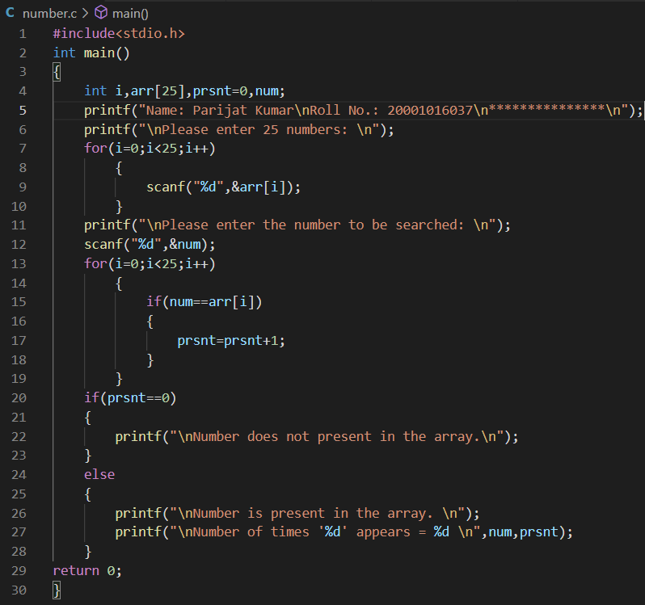Program:

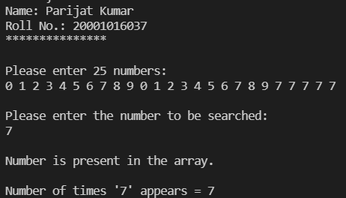Output:

Question 2)

Aim: Twenty-five numbers are entered from the keyboard into an array. Write a program to find out how many of them are positive, how many are negative, how many are even and how many odd.

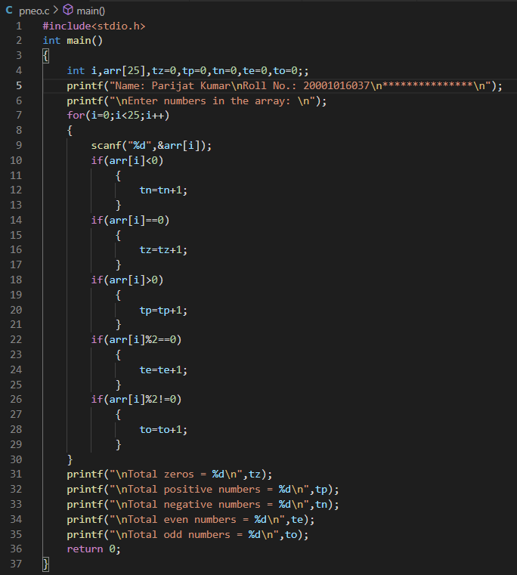Program:

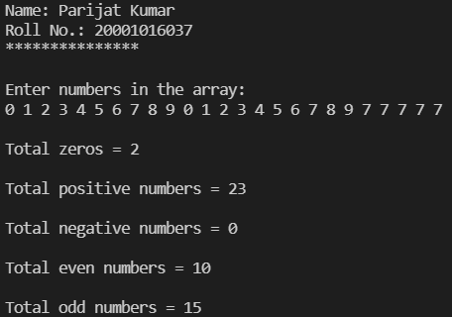Output:

Question 3)

Aim: Implement the Selection Sort, Bubble Sort and Insertion sort algorithms on a set of 25 numbers.

Program:

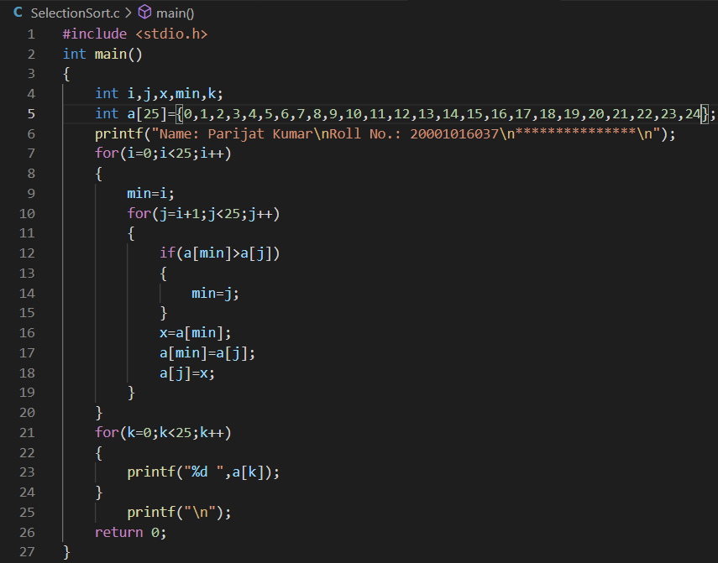Selection sort

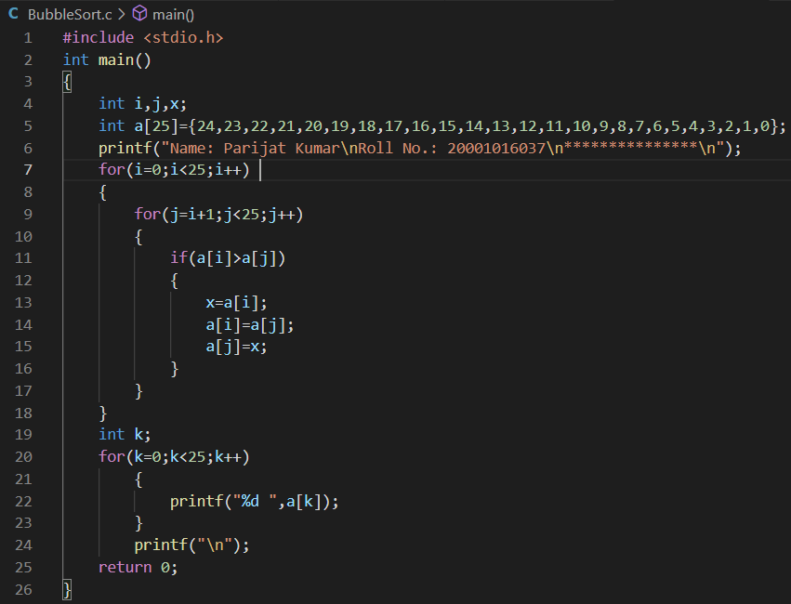Bubble Sort

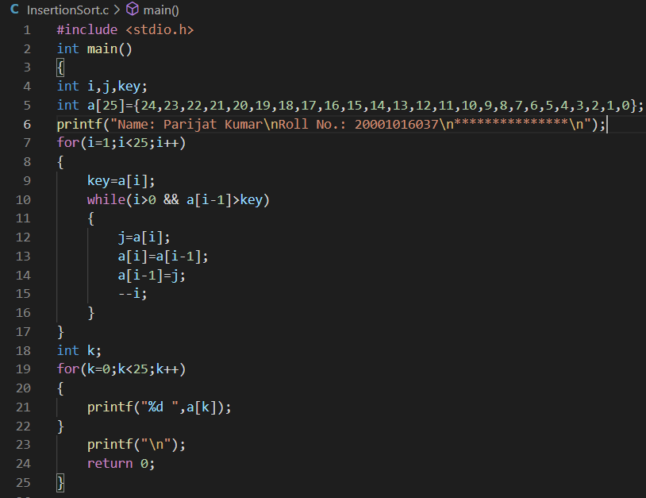Insertion Sort

Output:

Selection Sort

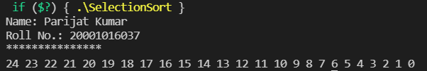Bubble Sort

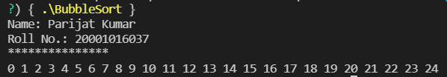

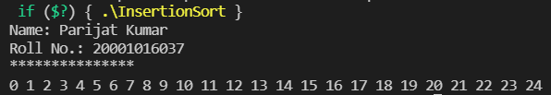Insertion Sort

Question 4)

Aim: Write a program to implement the procedure called Sieve of Eratosthenes to generate prime numbers from 1 to 100.

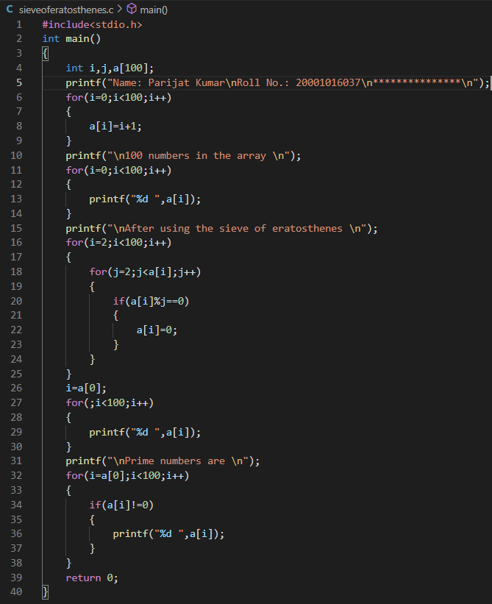Program:

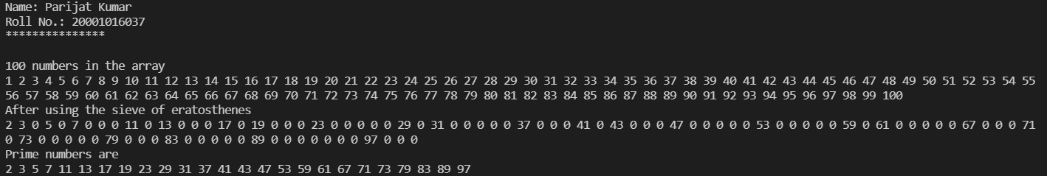Output:

Question 5)

Aim: Write a program to copy the contents of one array into another in the reverse order.

Program:

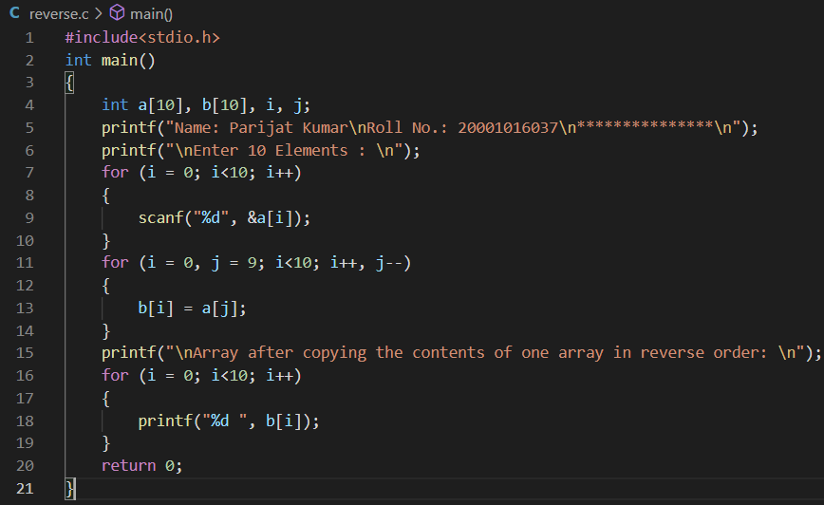

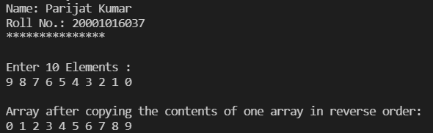Output:

Question 6)

Aim: If an array arr contains n elements, then write a program to check if arr[0] = arr[n-1], arr[1] = arr[n-2] and so on.

Program:

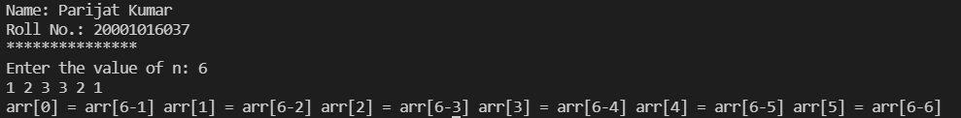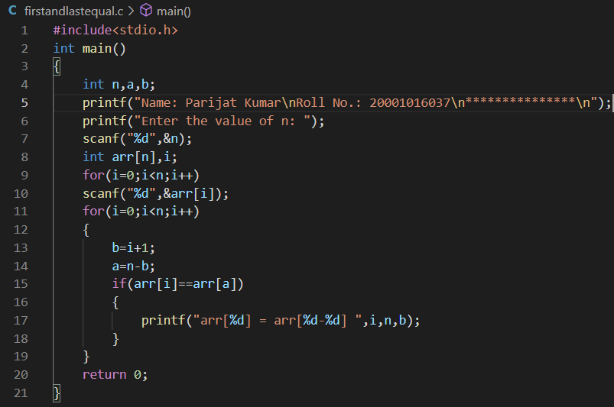Output:

Question 7)

Aim: Find the smallest number in an array using pointers.

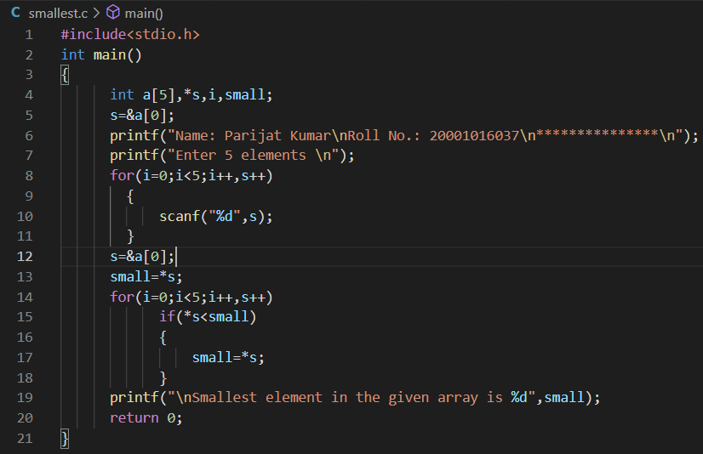Program:

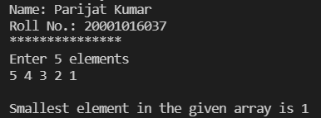Output:

Question 8)

Aim: Write a program which performs the following tasks:

− initialize an integer array of 10 elements in main ()

− pass the entire array to a function modify ()

− in modify () multiply each element of array by 3

− return the control to main () and print the new array elements in main ()

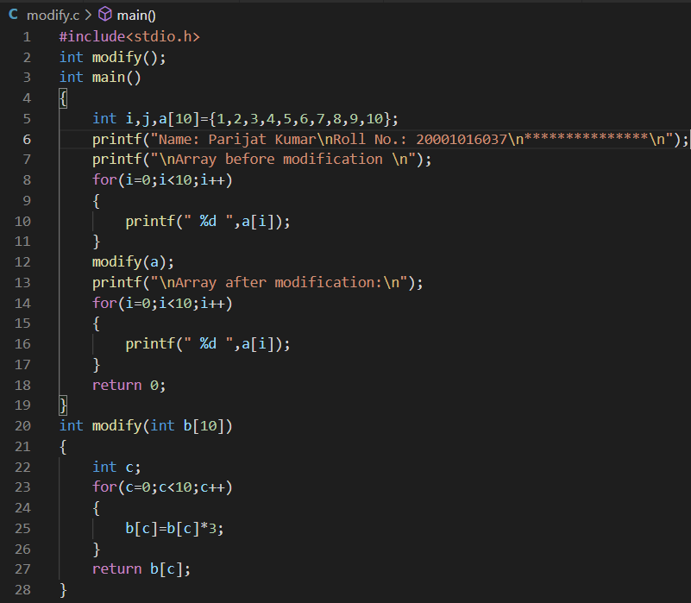Program:

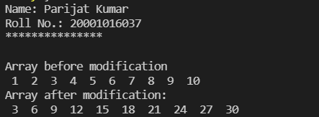Output:

Chapter – 9

Question 1)

Aim: Write a program that converts all lowercase characters in a given string to its equivalent uppercase character.

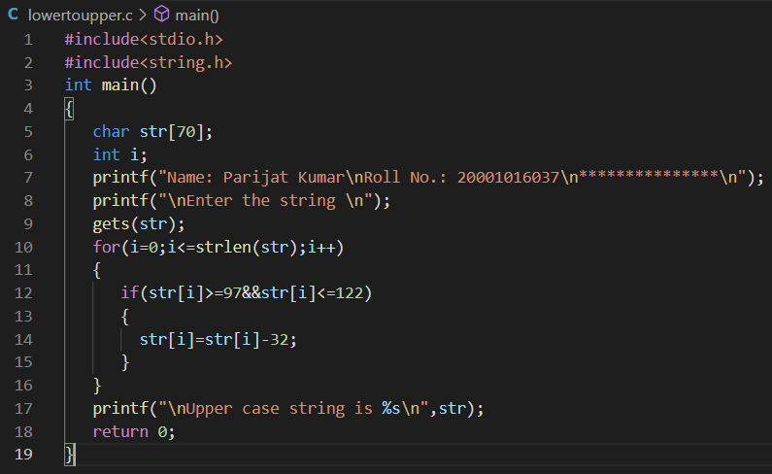Program:

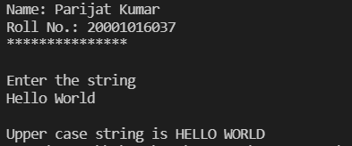Output:

Question 2)

Aim: Write a program that extracts part of the given string from the specified position.

Program:

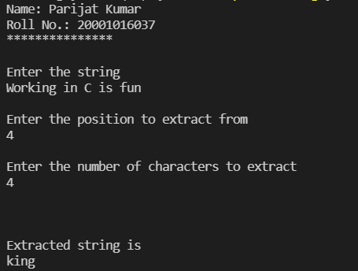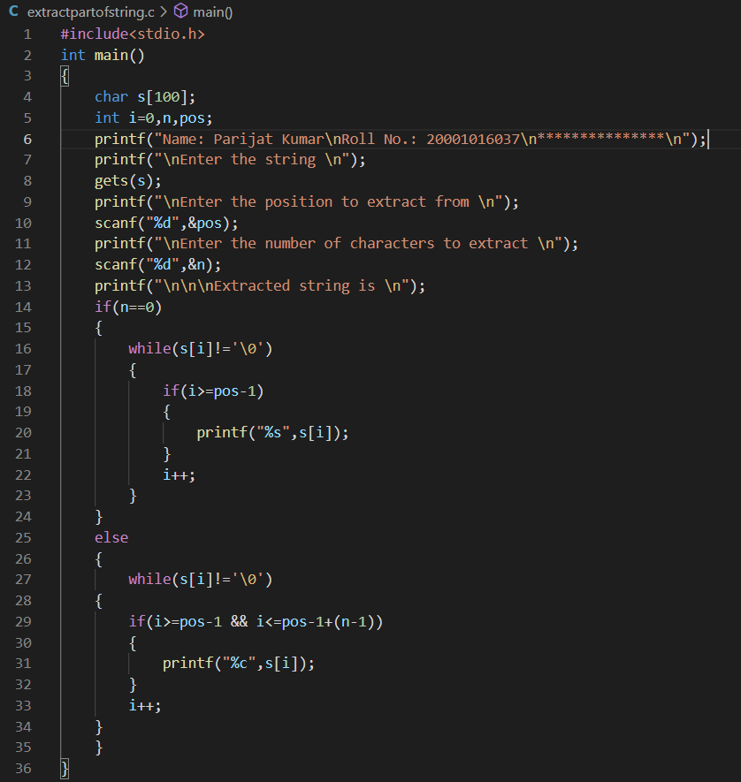Output:

Question 3)

Aim: Write a program that converts a string like "124" to an integer 124.

Program:

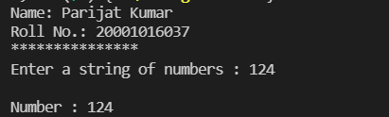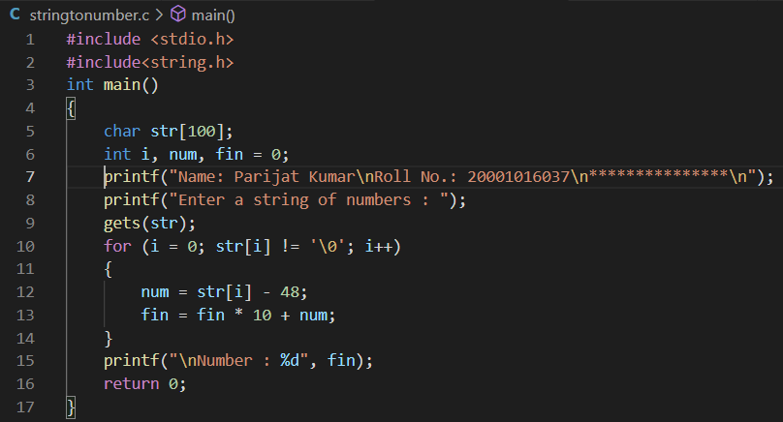Output:

Question 4)

Aim: Write a program that replaces two or more consecutive blanks in a string by a single blank.

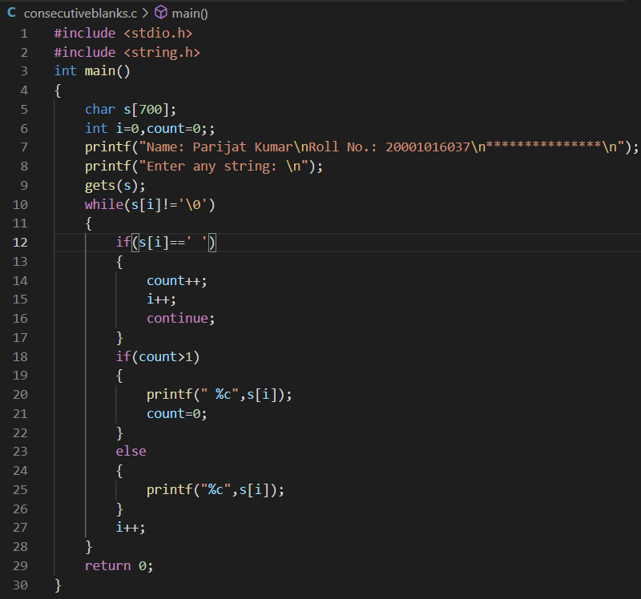Program:

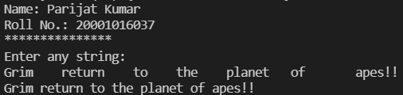Output:

Question 5)

Aim: Write a program that uses an array of pointers to strings str []. Receive two strings str1 and str2 and check if str1 is embedded in any of the strings in str []. If str1 is found, then replace it with str2.

char *str [] = {"We will teach you how to...",

"Move a mountain",

"Level a building",

"Erase the past",

"Make a million",

"...all through C!"};

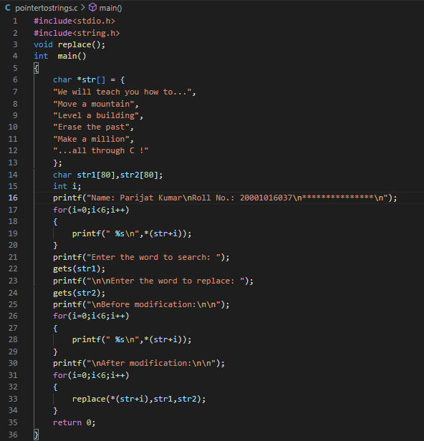Program:

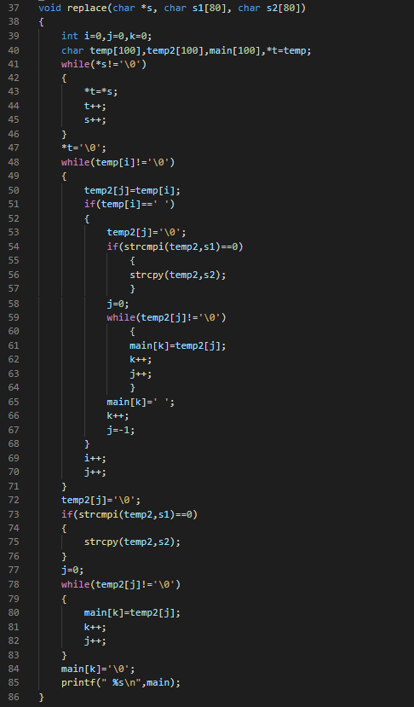

Output:

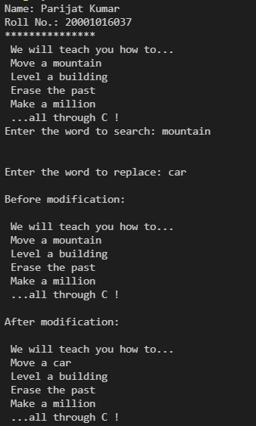

Question 6)

Aim: Write a program to sort a set of names stored in an array in alphabetical order.

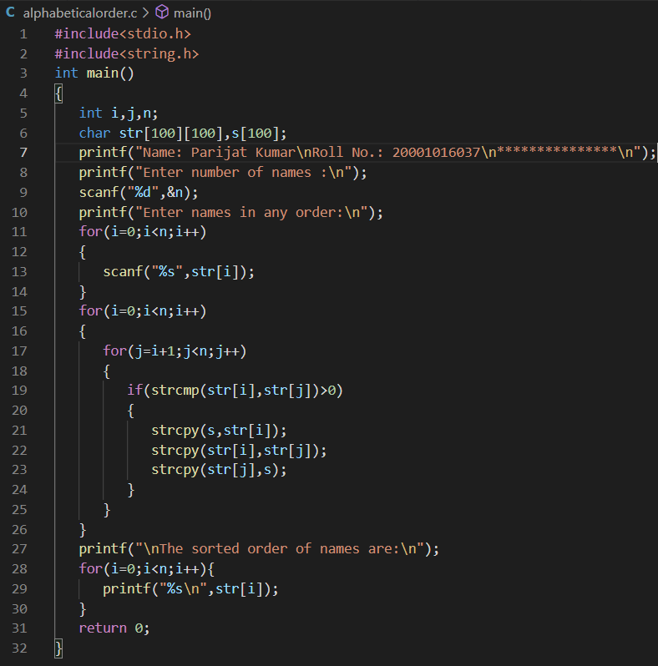Program:

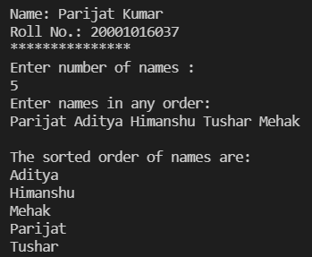Output:

Question 7)

Aim: Develop a program that receives the month and year from the keyboard as integers and prints the calendar.

Program:

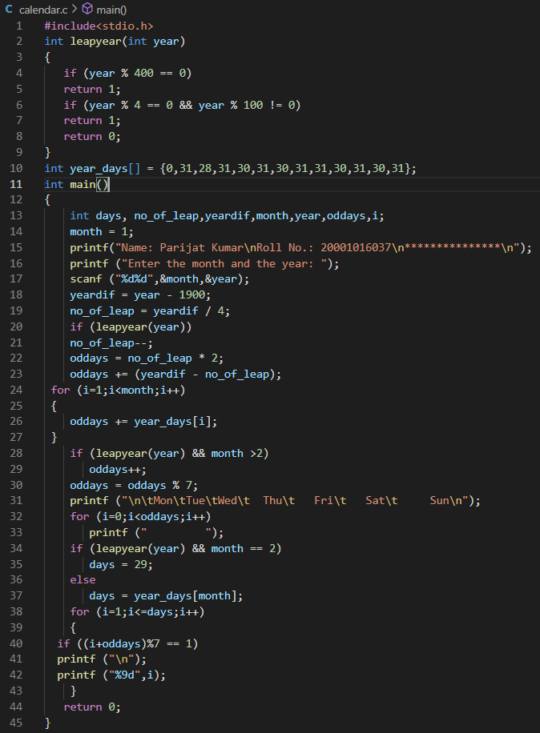

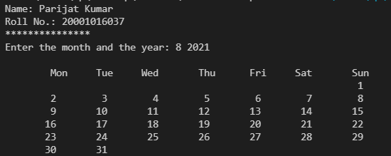Output:

Question 8)

Aim: Write a program to delete all vowels from a sentence.

Program:

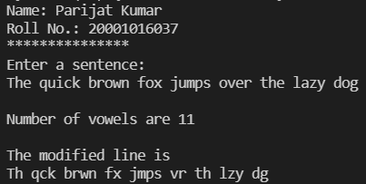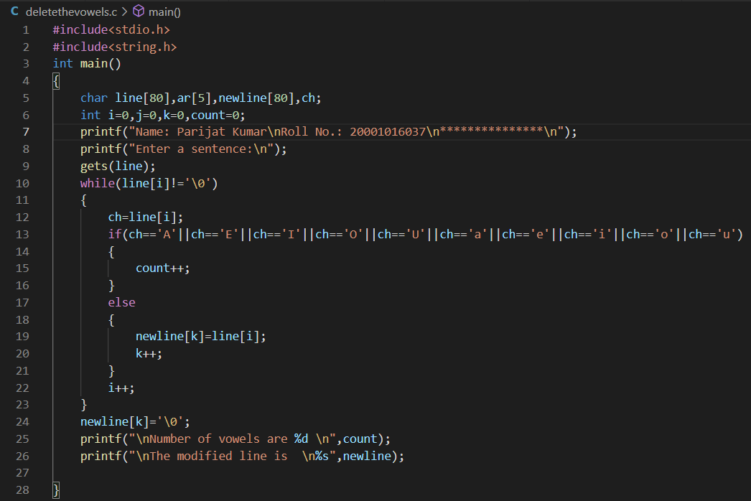Output:

Question 9)

Aim: Write a program that will read a line and delete from it all occurrences of the word ‘the’.

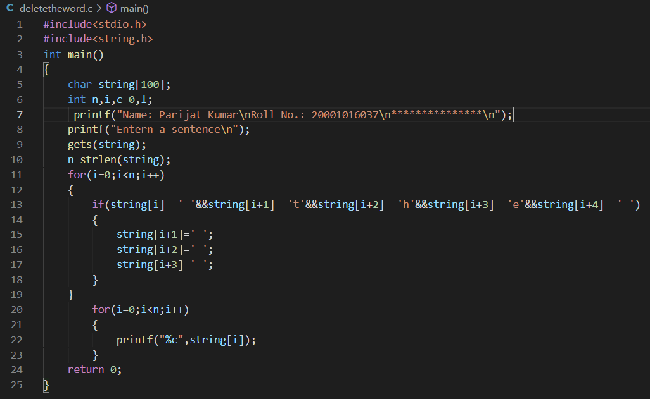Program:



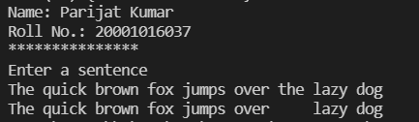Output:

Question 10)

Aim: Write a program to count the number of occurrences of any two vowels in succession in a line of text.

Program:

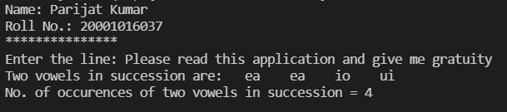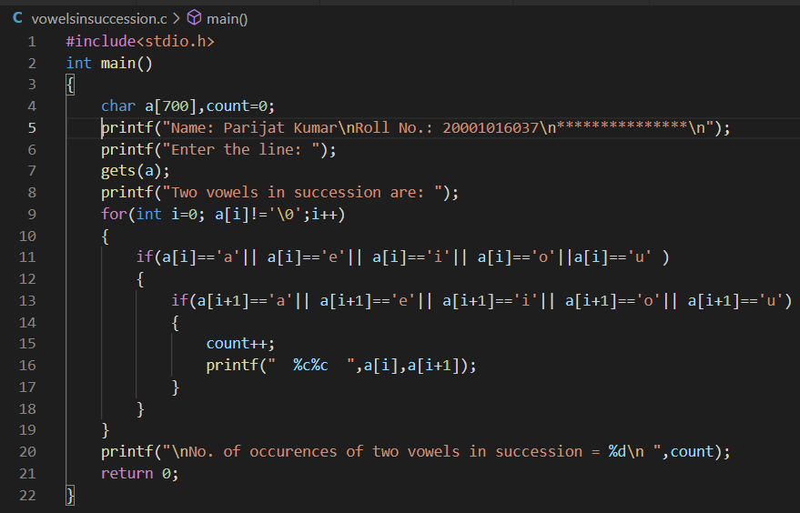Output:

Chapter-10

Question 1)

Aim: Create a structure to specify data of customers in a bank. The data to be stored is: Account number, Name, Balance in account. Assume maximum of 200 customers in the bank.

(a) Write a function to print the Account number and name of each customer with balance below Rs. 100.

(b) If a customer request for withdrawal or deposit, it is given in the form:

Acct. no, amount, code (1 for deposit, 0 for withdrawal). Write a program to give a message, “The balance is insufficient for the specified withdrawal”.

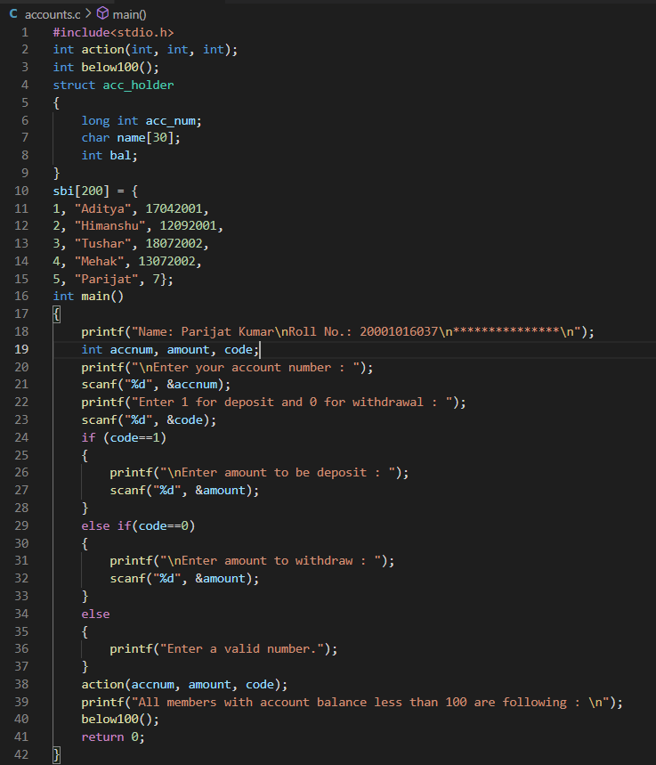Program:

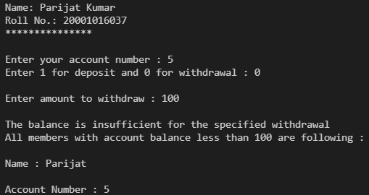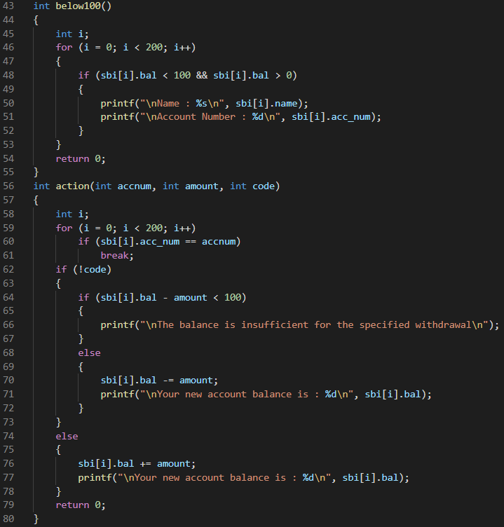Output:

Question 2)

An automobile company has serial number for engine parts starting from AA0 to FF9. The other characteristics of parts to be specified in a structure are: Year of manufacture, material and quantity manufactured.

(a) Specify a structure to store information corresponding to a part.

(b) Write a program to retrieve information on parts with serial numbers between BB1 and CC6.

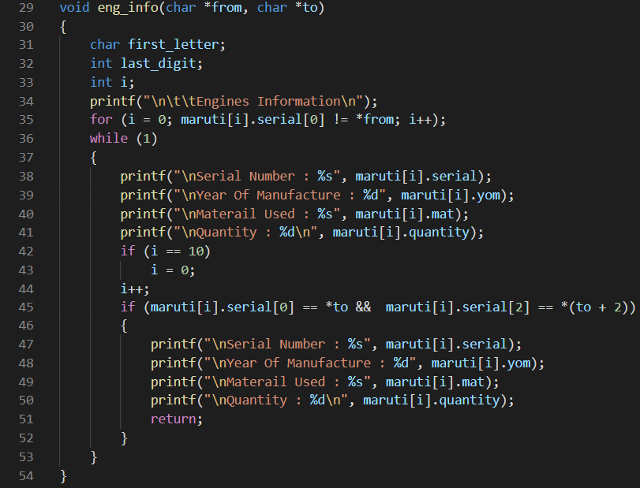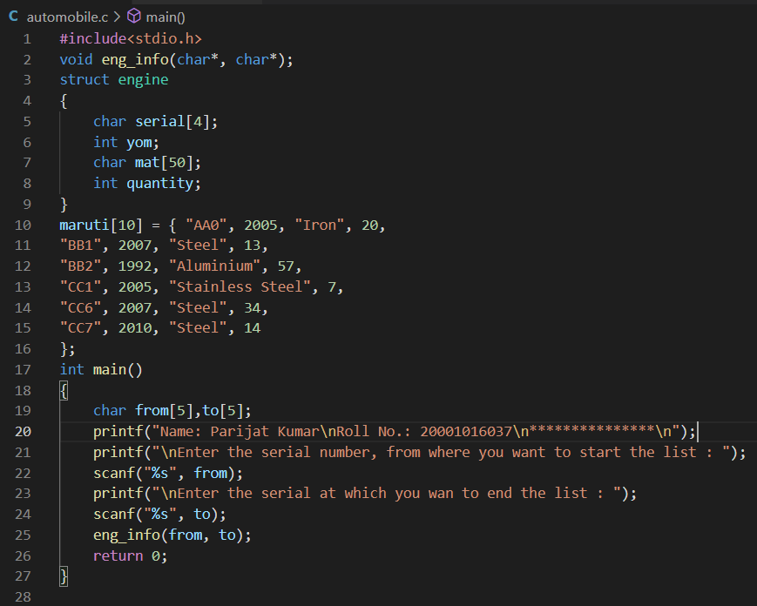Program:

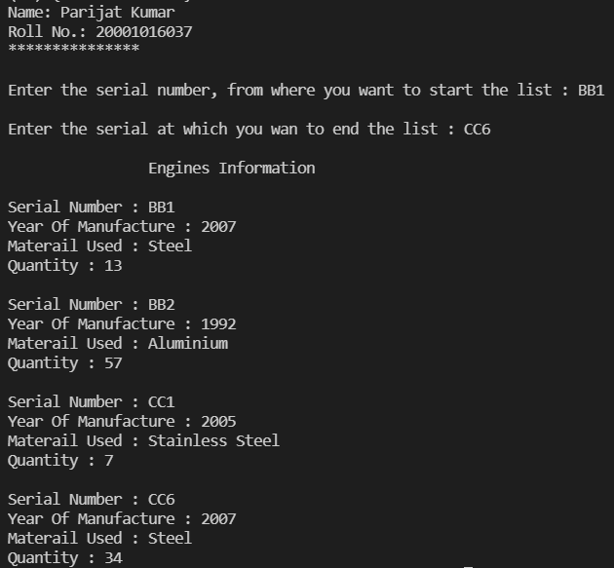Output:

Question 3)

Aim: There is a structure called employee that holds information like employee code, name, date of joining. Write a program to create an array of the structure and enter some data into it. Then ask the user to enter current date. Display the names of those employees whose tenure is 3 or more than 3 years according to the given current date.

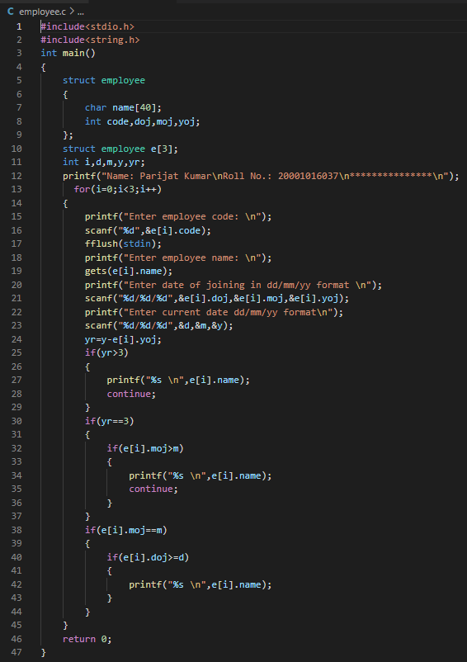Program:

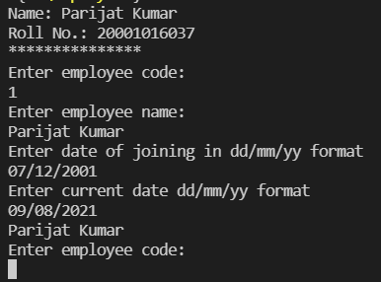Output:

Question 4)

Aim: Write a menu driven program that depicts the working of a library. The menu options should be:

1. Add book information 2. Display book information 3. List all books of given author 4. List the title of specified book 5. List the count of books in the library 6. List the books in the order of accession number 7. Exit

Create a structure called library to hold accession number, title of the book, author name, price of the book, and flag indicating whether book is issued or not.

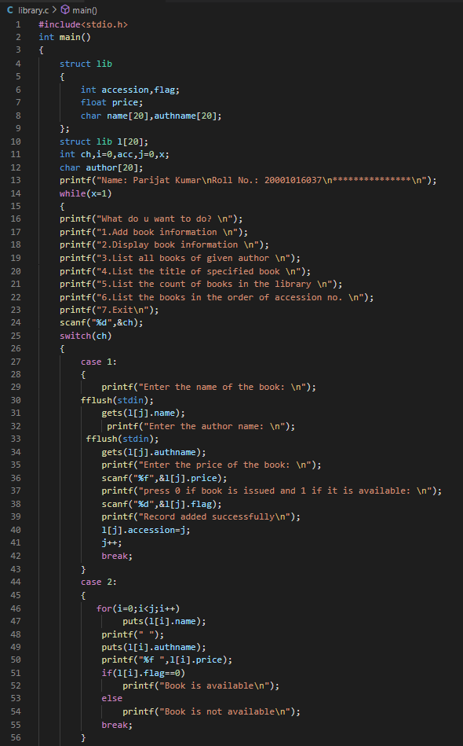Program:

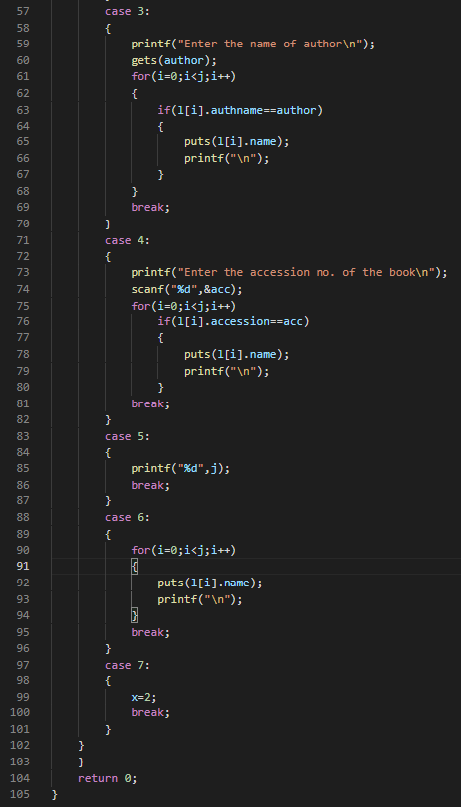

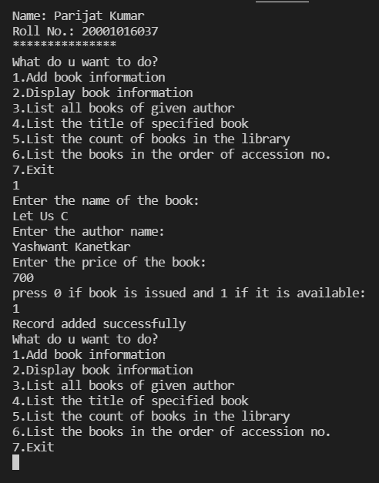Output:

Question 5)

Aim: Write a program that compares two given dates. To store date use structure say date that contains three members namely date, month and year. If the dates are equal then display message as "Equal" otherwise "Unequal".

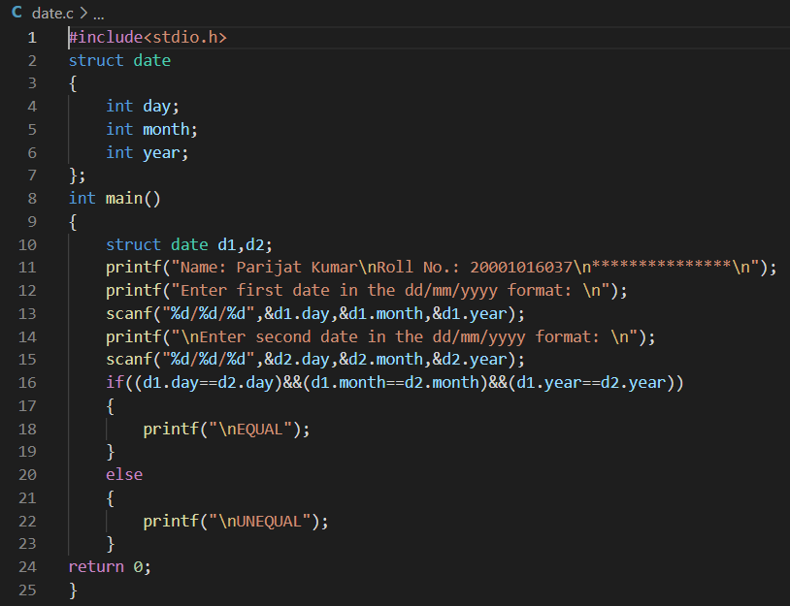Program:

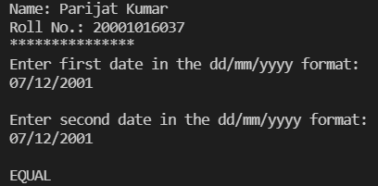Output:

Question 6)

Aim: Write a program to implement a stack using a linked list.

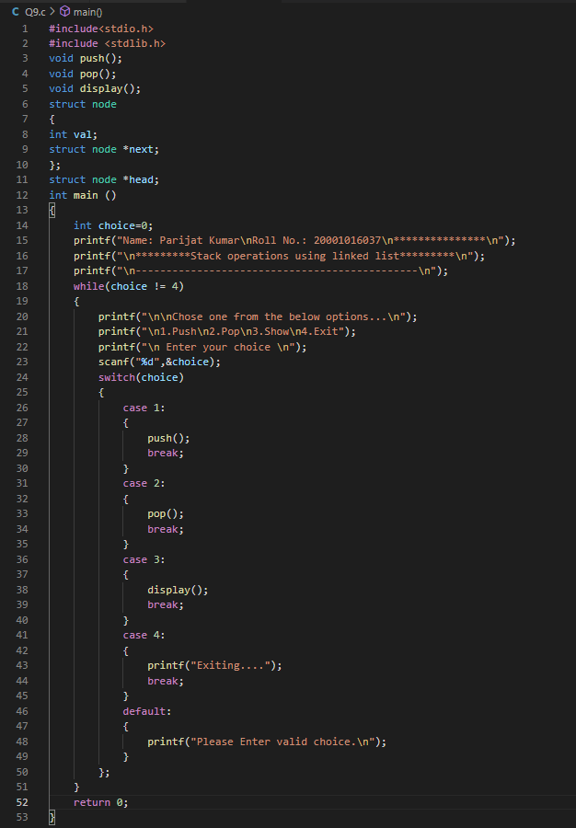Program:

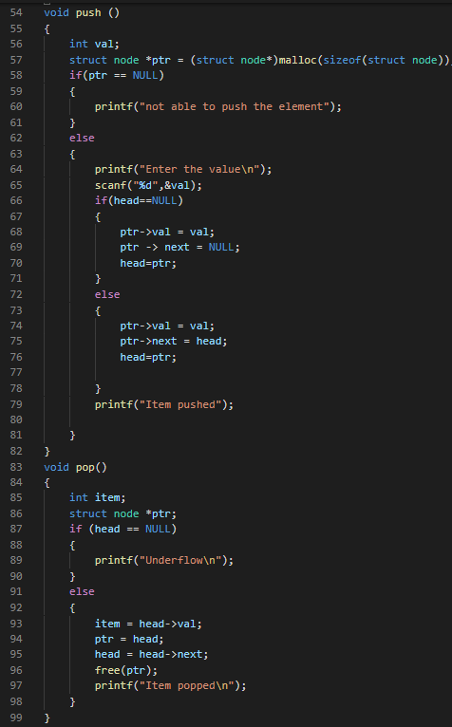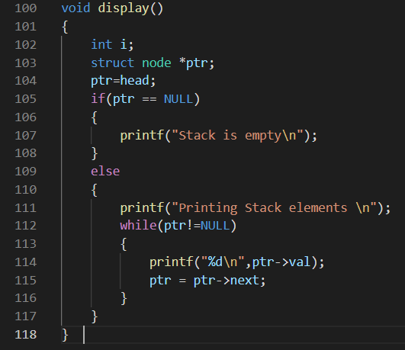

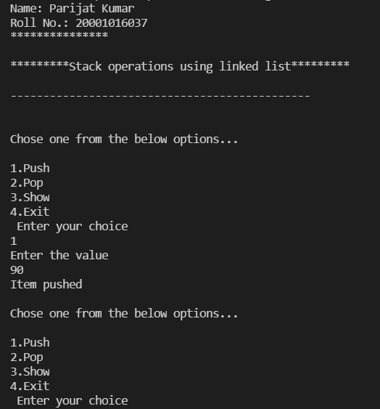Output:

Question 7)

Aim: Write a program to implement a queue using a linked list.

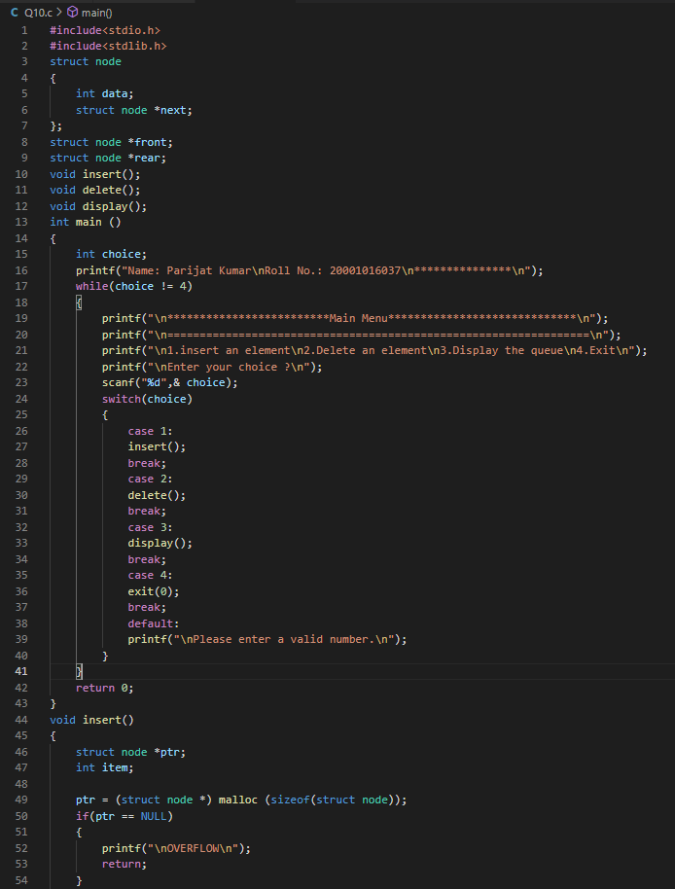Program:

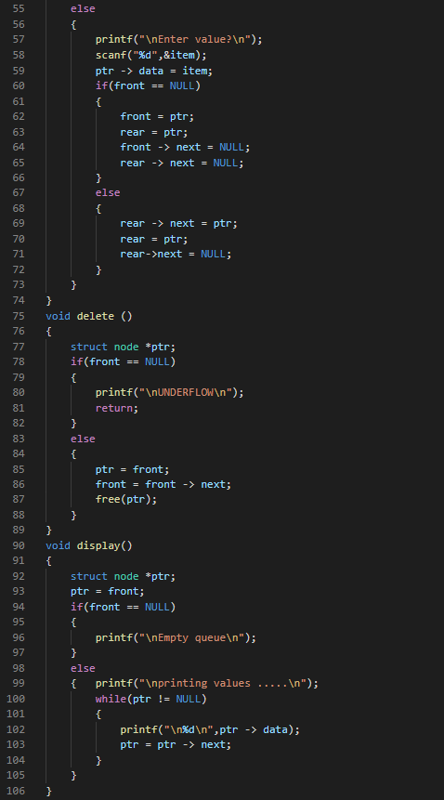

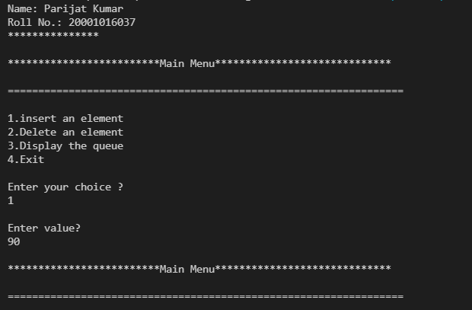Output:

Chapter-12&13(File Handling)

Question 1)

Aim: Write a program to read a file and display contents with its line numbers.

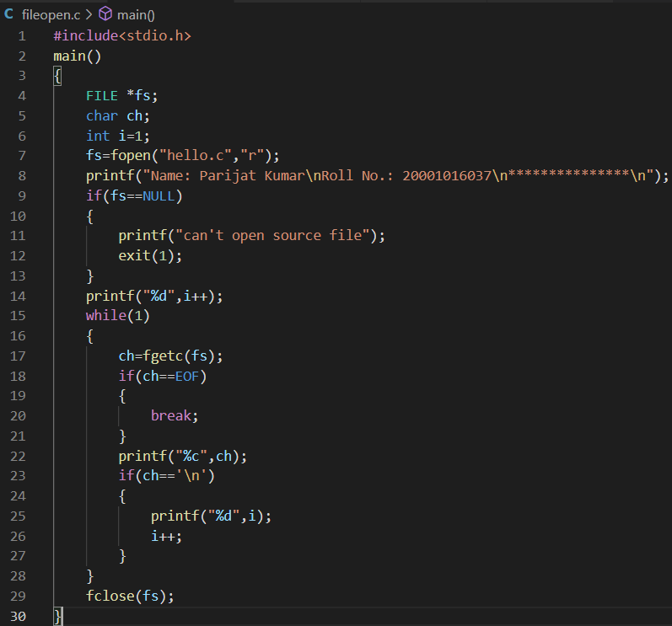Program:

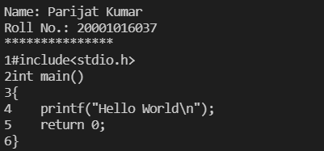Output:

Question 2)

Aim: Write a program to find the size of a text file without traversing it character by character.

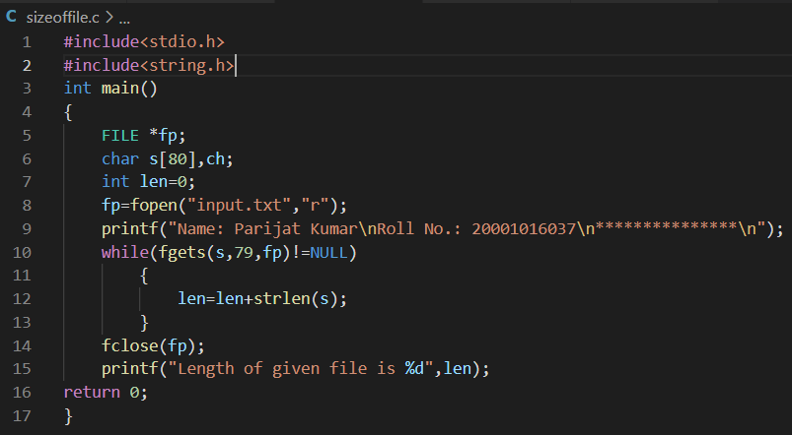Program:

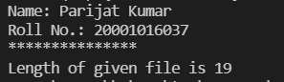Output:

Question 3)

Aim: Write a program to add the contents of one file at the end of another.

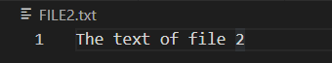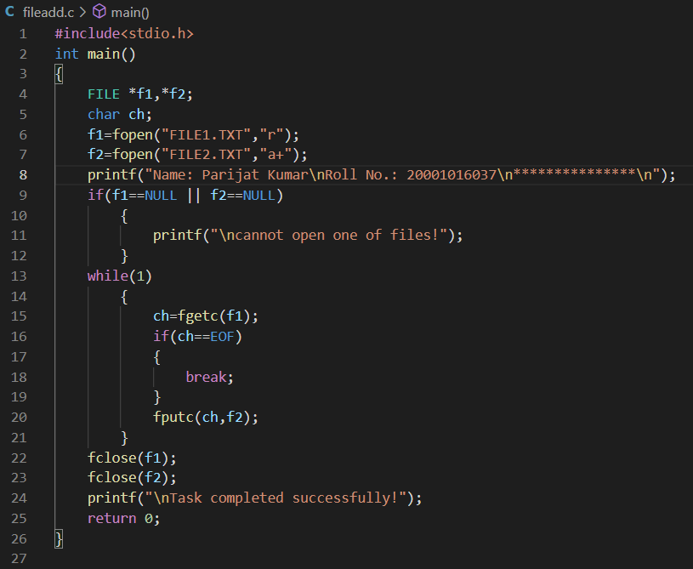Program:

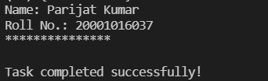Output:

Question 4)

Aim: Write a program to carry out the following:

(a) Read a text file ‘INPUT.TXT’

(b) Print each word in reverse order

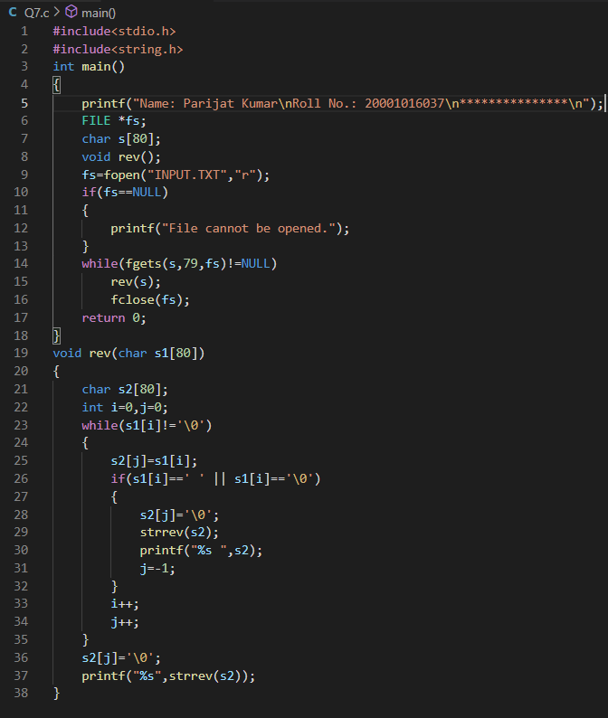Program:

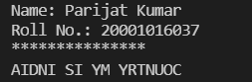Output:

Question 5)

Aim: Given a text file, write a program to create another text file deleting the words “a”, “the”, “an” and replacing each one of them with a blank space.

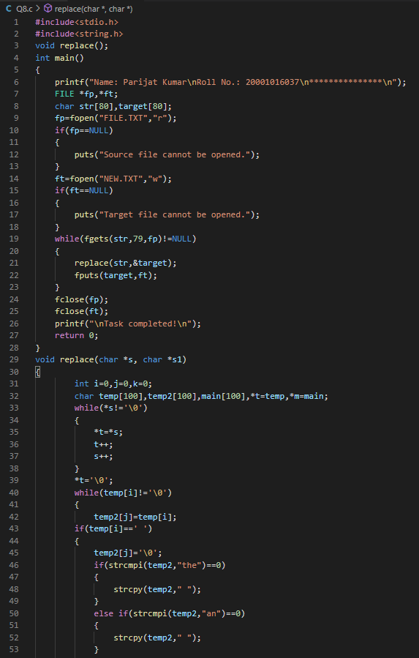Program:

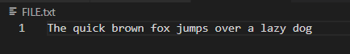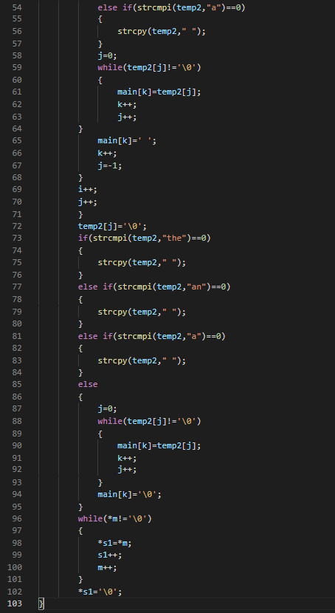

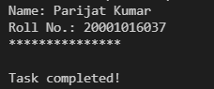Output:

